Palestinian Central Bureau of Statistics (PCBS)

On the Eve of the International Day of Refugees (20/06/2014)

66% of Palestinians who were living in Historic Palestine (British-Mandated Palestine) in 1948 were Expelled and Displaced

The human plight and tragedy that has befallen on the Palestinian people in 1948, a devastating tragedy was expelled and displaced from land seized by Israel as about 957 thousand Palestinian Arabs, representing 66.0 % of the total Palestinians who were living in historic Palestine on the eve of the war of 1948, according to UN estimates in 1950.

Number of Official Palestinian Camps as Recognized by UNRWA by the Residential Country

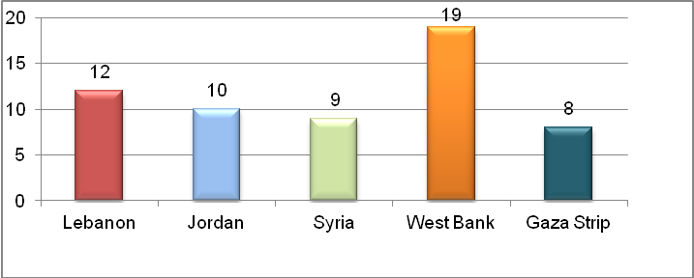
Source : According to the data of UNRWA on the Palestinian Refugees. http://www.unrwa.org

Several official estimates on the number of Palestinian refugees on the eve of the 1948 war was released from various sources, including official British, American, Palestinian and Israeli estimates as well as the United Nations estimates. However, United Nations released two estimates: the first referred to the number of Palestinian refugees that amounted to about 726 thousand refugees as based on the estimates of the United Nations in 1949. And the second that amounted to 957 thousand refugees as based on estimates of 1950.

5.4 million Registered Refugees in UNRWA
UNRWA Records indicated that the number of registered Palestinian refugees on the first of January 2014 amounted up to about 5.4 million and these figures represented the minimum number of Palestinian refugees. Palestinian refugees in West Bank who are registered with UNRWA as in the beginning of 2014 accounted up to 16.8 % of the total refugees registered with UNRWA against 24.1% in Gaza Strip. At the level of the Arab countries, the percentage of Palestinian refugees registered with UNRWA in Jordan, amounted up to 39.7% of the total Palestinian refugees while the percentage of Palestinian refugees registered with UNRWA in Lebanon and Syria reached 8.9% and 10.5% respectively.

Percentage Distribution of Palestinian Refugees by the Residential Country as in 1/1/2014, (According to the data of UNRWA on the Palestinian Refugees )

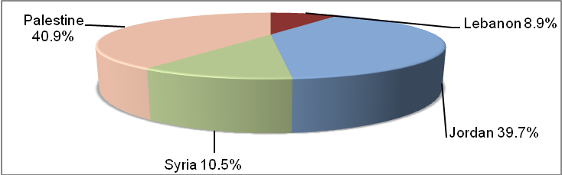
Source : According to the data of UNRWA on the Palestinian Refugees. http://www.unrwa.org

41% of the total Population in Palestine are Refugees
Data refer that the percentage of the population of refugees in Palestine in 2013 is estimated at 41.2% of the total Palestinian population living in Palestine, and data indicated that 26.1% of the population in West Bank are refugees, while the percentage of refugees in Gaza Strip is about 65.3%.

Percentage of Refugees in Palestine by Region in 2013

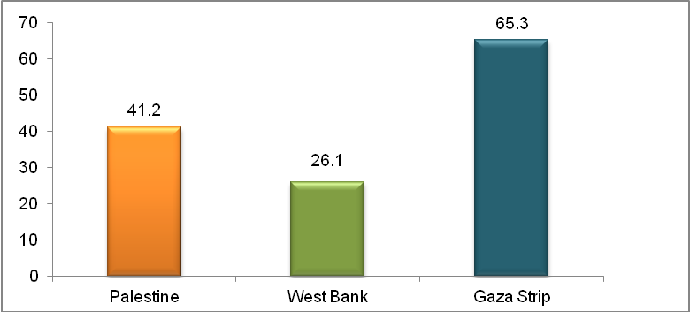
Source: Palestinian Central Bureau of Statistics 2014. Database of the Labor Force Survey,
the fourth quarter 2013. Ramallah -Palestine

Palestinian Refugees are Characterized as a Youngsters Community
Statistical data of 2013 indicated that the percentage of persons aged less than 15 years in Palestine reached 39.9% (as of 41.1% for refugees and 39.1% for non- refugees), while the percentage of elderly aged 60 years and over among refugee reached 4.2% of the total refugees while for non- refugees reached 4.5%.

Palestinian Refugee Women living in Palestine are the most Fertility
Statistical data of 2010 indicated that the total fertility rate for the period (2008-2009) in Palestine amounted to 4.4 births, and the average number of the children ever born amounted to 4.3 births for 2010. When compared to those rates by refugee status, it is clear to us that there are light differences between total fertility rates and the average number of children ever born as the total fertility rate and the average number of children among refugee reached 4.4 births and 4.3 births respectively, while these rates among non-refugee reached 4.3 and 4.2 births respectively .

Fertility Rates in the State of Palestine by refuge status (2008 -2009)

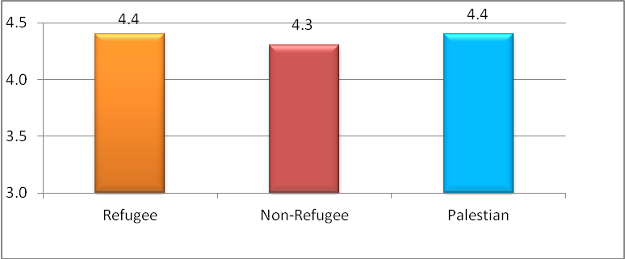
Source: Palestinian Central Bureau of Statistics, 2014. Database scanning Palestinian family 2010 .
Ramallah -Palestine

Palestinian Refugees are poorer than non-refugees
Poverty index showed that poverty rate in Palestine among refugees according to monthly household real consumption patterns reached 31.2% in 2011, compared to 21.8% for non-refugees

Data indicated that refugee population of camps in Palestine are poorer compared with rural and urban population. Data of real monthly consumption patterns showed that 35.4% of the camps in Palestine are suffering from poverty compared to 19.4% in rural areas and 26.1% in urban areas. These high rates of poverty in refugee camps may be traced back to high unemployment rates and large size of households in the camps compared with other households in urban and rural areas, as well as data indicated that their is high poverty rate in Gaza Strip as a whole where Gaza Strip has highest rates of poverty, regardless of locality type, as percentage of poverty among individuals in Gaza Strip reached 38.8% against 17.8% in West Bank.

Refugees are less participation in economic activities and more likely to unemployment
The results of the Labor Force Survey in 2013 showed that the rate of participation in labor force among refugees aged 15 years and over whom residing in Palestine were less than non- refugees since the rate reached 42.8% and 44.2% respectively. Also, the rate of female participation of refugee living in Palestine reached 17.3% against 17.2% for non- refugees. Data indicated that there is a clear difference on the level of unemployment among refugees and non-refugees, as unemployment rate among refugees reached up to 28.3% compared to 20.1% among non-refugees.

One-third of the Refugees are working as Specialists and Technicians
In 2013, the profession of "technicians, specialists, assistant, and clerks" considered as the most accommodating profession among refugees and non- refugees in Palestine alike as refugees amounted to 33.1% while the non-refugees reached 23.2%. Also, legislators and senior management staff represented the lowest percentage for both of refugees and non-refugees with a variation by 3.2% for refugees and 3.8% for non-refugees.

Half of Youth didn’t yet start the Transition from Education to the Labor Market
The results of the transition youth from education to the labour market survey in 2013 in Palestine indicated that 15.6% of refugee youth completed their transition to stable jobs in the labour market compared with 20.1% among non refugee youth, while 3.7% of youth refugee completed their transition to temporary jobs or as self-employed compared with 4.6% for non refugee youth, 34.2% of refugee youth pass in the period of transition compared with 30.2% among non refugee youth, while 46.5% of refugee youth didn’t yet start the transition period compared with 45.1% of non-refugee youth.

An Increase in Percentages of Educational Attainment among Refugees
The percentage of illiteracy among Palestinian refugees in 2013 in Palestine for individuals aged 15 years and over reached 3.3%, while among non-refugee reached 4.0 %. As a percentage of Palestinian refugees aged 15 years and over who obtained a bachelor's degree or higher reached 12.8 % of the total refugees aged 15 years and over against 11.5 % for non-refugees .

About 60% of the Refugee Households live in an Apartment
Data of 2013 indicated that 47.3% of the households of Palestine live in an independent house, the percentage among non-refugee was 54.2% against 36.9% for refugees, and the percentage of household living in an apartment reached 50.8% (44.5% non-refugee against 60.2% for refugee). The percentage of refugee households living in a rented accommodation reached 10.9% of the total refugee households and 77.8% for refugee households are living in a private residence.

Difference in Percentage of Information Technology Tools and Communication between Refugee and Non-Refugee Households
Data on information technology tools and communication with the households indicated that the percentages provide a means of information and communication among non-refugee households differ from percentages of refugee households, while the percentages of non-refugee households that are available for their fix phone reached 34.5% for non- refugee households against 36.9% for refugee households. The percentage of non-refugee households that are available for their a smart phone 24.8% while the percentage of the refugee households 17.0%, and, the percentage of availability of a computer with non-refugee households 54.6% while the value of the refugee households 51.9%, and about the availability of Internet service at home, the percentage of households refugee 34.7% versus 37.7% for non-refugee households.

