Palestinian Central Bureau of Statistics (PCBS)

On the Eve of International Literacy Day, 8th September

On the eve of the International Literacy Day, 8th September 2015, the President of Palestinian Central Bureau of Statistics announced that there were about 98 thousands illiterate persons in Palestine aged 15 years and above in 2014. According to the United Nations for Educational, Scientific and Cultural Organization (UNESCO) – the illiterate person applies to persons unable to read or write in any language and who were never awarded a certificate from any formal educational system.

The illiteracy rate among females is three and a half times that of males
In 2014, the illiteracy rate among persons 15 years and above in Palestine was 3.6% (97,921 illiterate): 3.8% in the West Bank (66,547 illiterate) and 3.1% in Gaza Strip (31,374 illiterate). The illiteracy rate varies considerably between sexes: 1.6% for males (22,161 illiterate) compared to 5.6% for females (75,760 illiterate) in the same year.

A rise in illiteracy rate in rural areas compared to other localities
In 2014, the illiteracy rate among rural localities reached 5.0% (25,190 illiterate), while scored 3.3% (64,321 illiterate) in urban areas and 3.2% (8,410 illiterate) in the refugee camps. In 2014, the male illiteracy rate was highest in rural localities, followed by urban areas and refugee camps with the same rate. Female illiteracy rate was highest in rural localities, followed by urban areas and refugee camps respectively.

Illiteracy rate for persons (15 years and above) in Palestine by locality type and sex, 2014

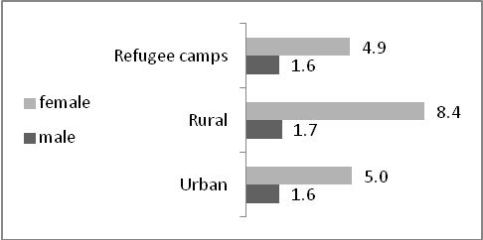

The illiteracy rate among older persons aged 65 years and above was the highest across age groups
In 2014, the illiteracy rate among older persons aged 65 years and above attained 43.0% (57,611 illiterate). The rate was 1.5% in the 15-64 year age group (40,310 illiterate) and 0.6% among young people aged between 15-24 years (6,293 illiterate) in the same year.

The highest illiteracy rate was in Jericho and Al Aghwar Governorate
In 2014, the highest illiteracy rate among persons aged 15 years and above was in Jericho and Al Aghwar governorate, scoring 6.0%, followed by Tubas governorate with 5.5%. The lowest rate was in Gaza governorate with 2.7%, followed by North Gaza governorate with 3.0%.

The illiteracy rate among persons 15 years and above in Palestine is one of the lowest in the world
According to UNESCO Institute for Statistics, the illiteracy rate among persons 15 years and above in Arab States was 22.5% (about 51.8 million illiterate) in 2012: for males, 14.9% (17.6 million illiterate) compared to 30.8% for females (34.2 million illiterate). For the same year, the rate was 15.7% (about 781.2 million illiterate) in the world among the same age group: for males. 11.4% (284.8 million illiterate) compared to 19.8% for females (496.4 million illiterate).

The illiteracy rates reduced in Palestine from 13.9% in 1997 to 3.6% in 2014
Illiteracy rates among persons aged 15 years and above in Palestine fell in the period 1997-2014 from 13.9% to 3.6%. For males, the rate fell from 7.8% in 1997 to 1.6% in 2014, while for females it fell from 20.3% to 5.6% over the same period.

Illiteracy rates for persons (15 years and above) in Palestine by sex for years 1997, 2000-2014

