Palestinian Central Bureau of Statistics (PCBS)

- 2.7% of Individuals in Palestine Suffered from at Least One Disability in 2011
- Mobility is Most Common Disability in Palestine
- Around 1,134 individuals injured in the war on Gaza Strip in 2014 are expected to be left disabled
War on Gaza Strip
Preliminary findings from the Ministry of Health in the Gaza Strip indicate that approximately 1,134 individuals injured in the recent war on the Gaza Strip are anticipated to be disabled with at least one disability: 833 individuals 18 years and over, and 301 individuals under 18 years. They make up about 10% of the 11,232 individuals injured in the war.

Prevalence of Disability in Palestine
In 2011 data shows that around 113 thousand individuals suffer from at least one disability and constitute 2.7% of the population in Palestine: 75 thousand in the West Bank 2.9%, and around 38 thousand in the Gaza Strip 2.4%. By gender, 2.9% are males and 2.5% are females.

Percentage of Disabled Individuals by Sex and Region, 2011 ‏
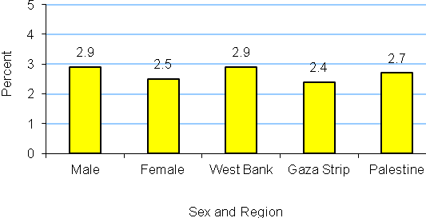

Prevalence of Disability Increases with Age, 2011
The prevalence of disability is strongly related with age. Disability rates are significantly higher among individuals aged 75 and above at 32.0%: 28.9% of males and 34.1% of females. Among children, the percentage was 1.5%: 1.8% of males and 1.3% of females.

Highest Percentage of Disabilities in Jenin Governorate, Lowest in Jerusalem, 2011
In Jenin governorate, 4.1% of individuals have a disability, followed by Hebron governorate with 3.6%. The figure for Jerusalem was 1.4%. In the Gaza Strip, the highest prevalence was reported in Gaza governorate with 2.5%, followed by North Gaza, Rafah and Deir Al Balah governorates with 2.4% for each governorate. The lowest prevalence was 2.2% in Khan Yunis governorate.

Mobility is Most Common Disability, 2011
Mobility is the most prevalent disability and affects 48.4% of disabled individuals in Palestine: 49.5% in the West Bank compared with 47.2% in the Gaza Strip. Learning disability is the second most prevalent with 24.7%: 23.6% in the West Bank and 26.7% in the Gaza Strip.

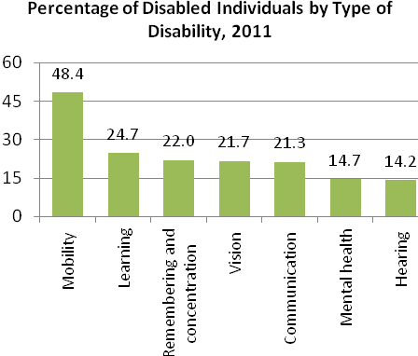
Main Cause of Disabilities is Illness
The main cause of all disabilities covered in the survey was illness, according to 2011 data. Illness was the main cause of 43.7% of visual disabilities; 29.1% of hearing disabilities; 42.9% of mobility disabilities; 28.7% of disabilities related to memory and concentration; 27.6% of learning disabilities; and 27.2% of mental disabilities. Congenital problems were the main cause of communication disabilities 33.6%.

More than one third of disabled individuals aged 15 years and above have never been to school
In Palestine 37.6% of all disabled individuals aged 15 years and above in 2011 had never been enrolled at school: 35.5% in the West Bank and 42.2% in the Gaza Strip. In addition, 33.8% of all disabled individuals had dropped out of school: 37.0% in the West Bank and 27.1% in the Gaza Strip. The illiteracy rate among disabled individuals was 53.1%: 51.5% in the West Bank and 56.3% in the Gaza Strip.

Majority of disabled individuals aged 15 years and above do not work
In 2011, 87.3% of all disabled individuals were unemployed: 85.6% in the West Bank and 90.9% in the Gaza Strip.

One of every three disabled individuals aged 15 years and above is never married
Data of 2011 shows that, 34.1% of disabled individuals are never married: 35.7% in the West Bank and 30.7% in the Gaza Strip, while 44.5% of all disabled individuals are married, with similar percentages in both the West Bank and Gaza Strip. Widowed individuals (both sexes) constituted 18.2%: 15.9% in the West Bank and 23.1% in the Gaza Strip, and 2.4% were divorced (both sexes): 2.8% in the West Bank and 1.6% in the Gaza Strip.

Impact of environmental and physical obstacles on lives of disabled individuals aged 18 years and above, 2011
- Avoid interaction with others
In Palestine 8.7% of disabled individuals commonly avoid engaging in any activities because of public attitudes towards them: 9.5% in the West Bank and 7.7% in the Gaza Strip.

- Inability to use public transportation
In Palestine 76.4% of disabled individuals aged 18 years and above do not use public transportation due to the absence of required adaptations in the infrastructure: 75.5% in the West Bank and 78.1% in the Gaza Strip.
.
- Difficulties in daily activities
In Palestine 34.2% of disabled individuals stated that they were unable to perform daily activities outside their homes due to their disability: 32.1% in the West Bank and 38.4% in the Gaza Strip.

- More than one-fifth of disabled individuals dropped out of school due to environmental and physical obstacles
In Palestine 22.2% of disabled individuals dropped out of school due to environmental and physical obstacles: 23.2% in the West Bank and 19.4% in the Gaza Strip. Of these, 21.7% were male and 22.9% female.

