Palestinian Central Bureau of Statistics (PCBS)

On the occasion of May 1st - International Workers Day

Ms. Ola Awad, President of PCBS, presents the current status of Palestinian labour force during 2013

Participation of men in the labour force is four times higher than the participation of women
The participation rate in the labour force of persons aged 15 years and above in Palestine was 44% distributed as 69% for males and 17% for females. On the level of the West Bank, the participation rate was 45%; 71% for males compared to 18% for females. Regarding Gaza Strip, about 41% of persons participated in the labour force; 66% for males and 16% for females.

Labour Force Participation Rate of Persons Aged 15 Years and Above by Sex, 2007-2013

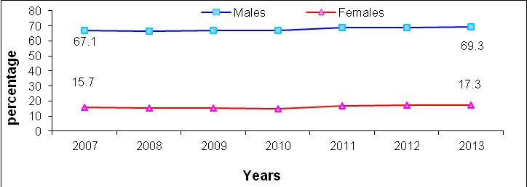

High unemployment rates
The unemployment rate among participants aged 15 years and above in Palestine was 23% (About 270 thousand persons were unemployed); 21% for males and 35% for females. The unemployment rate in the West Bank was 19% ( about 141 thousand); 17% for males and 26% for females, compared with 33% in Gaza Strip (129 thousand); 28% for males and 53% for females.

Unemployment Rate of Participants in the Labour Force Aged 15 Years and Above by Region, 2007-2013

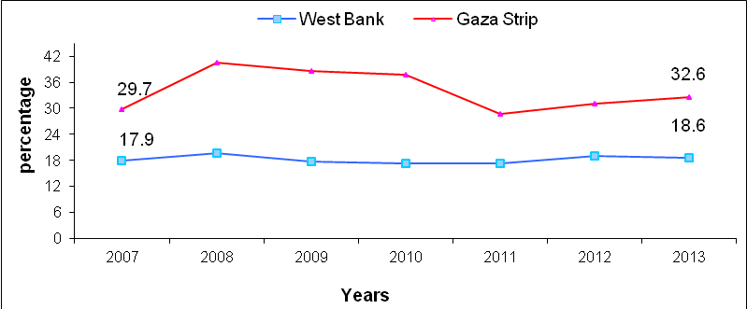

602 thousand of employed are wage employees
The number of wage employees in Palestine amounted to 602 thousand, of whom 312 thousand employed in the West Bank and 196 thousand employed in Gaza Strip; while 76 thousand employed in Israel and 18 thousand employed in Israeli settlement.

The Public Sector is the dominant employer in Gaza Strip
About 50% of wage employees in Palestine worked in the private sector compared with 34% work in the public sector; while the percentage of workers in Israel and Israeli settlements reached 16%.
Regarding wage employees in the West Bank, more than half employees 52% work in the private sector compared with 25% in the public sector and 23% work in Israel and Israeli settlements. The public sector was the largest employer in Gaza Strip with 52% compared with 48% in the private sector.

About one fifth of wage employees are poor
About 22% of wage employees are poor in Palestine in 2011; 16% in the West Bank and 35% in Gaza Strip.

More than one third of wage employees in the private sector work in technical and specialized occupations
About 24% of wage employees work as professionals or technicians in Palestine; 15% for males and 67% for females. In addition, 19% of wage employees in Palestine work in craft occupations; 22% for males and 4% for females.

On the other hand, about 19% of wage employees in the private sector in Palestine received vocational training; 19% in the West Bank and 20% in Gaza Strip.

Low average real wages in the private sector
The average daily real wage in the private sector in Palestine was 53 NIS; 59 NIS in the West Bank (workers in Israel and Settlements are excluded) and 40 NIS in Gaza Strip.

Services sector in the private sector recorded the highest average daily real wage at 71 NIS in the West Bank and 66 NIS in Gaza Strip, followed by transport and communication sector with 68 NIS in the West Bank and 31 NIS in Gaza Strip. The agriculture sector recorded the lowest average daily wage at 41 NIS in the West Bank and 17 NIS in Gaza Strip.

In West Bank, about 24.5% of wage employees were in the private sector who received less than minimum monthly wage about 51,300 wage employees with an average of monthly wage by 1,056 NIS. the large number of those who received less than the minimum monthly wage was in Hebron governorate of about 11,700 persons with average of monthly wage by 1,016 NIS.

In Gaza Strip, the percentage of wage employees in the private sector who received less than minimum of monthly wage was 67.5% of about 64,100 wage employees with an average of monthly wage 804 NIS. the large number of those who received less than the minimum of monthly wage was in Gaza governorate of about 26,500 persons with an average of monthly wage by 825 NIS.

The average weekly work week in hours in Palestine was 42 hours; 39 hours for employed persons in the public sector, 43 hours in the private sector.

About one fifth of wage employees received retirement benefits
About 21% of wage employees received retirement or end of service benefits; while 22% received paid annual leave and 23% received paid annual sick leave. In addition, 40% of wage employees females received paid maternity leave.
More than 93% of wage employees in the public sector received most of work related benefits and privileges such as paid sick leave, annual leave, maternity leave,…etc.

About one fourth of wage employees in the private sector have work contract
27% of wage employees in the private sector have work contract in Palestine; 26% in the West Bank and 27% in Gaza Strip.

About one fourth of wage employees in the private sector are affiliated to labour or professional unions
23% of wage employees in Palestine were affiliated to labour or professional union; 12% in the West Bank and 48% in Gaza Strip.

