The Palestinian Central Bureau of Statistics and the Ministry of Telecommunications and Information Technology Issue a Press Release
on the Occasion of World Information Society Day, May 17, 2013

Financial Intermediation sector occupied the first rank for using computer
47.0% of the total number of the establishments used computers in Palestine, (49.6% in the West Bank and 40.8% in Gaza Strip). Noticeably, the highest rate for computer use was 97.1% for establishments in Financial Intermediation sector. On the other hand, the lowest rate was 26.3% for the establishments in Industrial sector.

While occupied the Information and Communications sector ranked first in the use of the Internet among that using computer, followed by the financial intermediation sector (99.3%, 97.8%), respectively, in 2011.

E-commerce and economic establishments
28.5% of establishments that access to the Internet conducted e-commerce transactions in 2011, (26.2% in the West Bank and 35.4% in Gaza Strip).

Penetration of ICT tools in the economic establishments
Two third of establishments with ten employees or more have computer and a mobile phone and fixed phone and have an Internet connection, while half of the establishments with (5-9) employees have these tools, and one fifth of establishments with (0-4) employees have these tools in 2011.

5 per 100 Employees specialized in ICT The number of ICT specialists, employed by economic establishments in 2011 was 5.2 employees per 100 Employees. The number of employees who use computer in 2011 was 47.9 per 100 employees in Palestine, (52.6 employee of establishments in the West Bank and 31.7 employee of establishments in Gaza Strip).

Half of Palestinian households own a computer
51.4% of households owned a computer in Palestine in 2012: 55.2% in the West Bank and 44.2% in Gaza Strip. In 2006, around one third (32.8%) of households had a computer.

Percentage of Households having Computer by Region, Selected Years

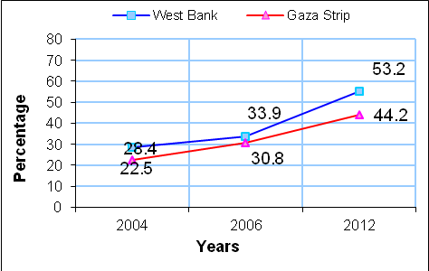

In 2012, 32.1% of households in Palestine had an Internet connection: 34.3% in the West Bank and 27.9% in Gaza Strip.

40.0% of households in Palestine had have a phone line in 2012: 42.7% in the West Bank and 34.8% in Gaza Strip.
95.7% of households in Palestine have a mobile phone in 2012.

More than half of youth using the Internet
Noticeable Increase in the Percentage of Having the Internet Among households and individuals. 30.4% of households in Palestine have an Internet connection compared to 9.2% in 2004. 55.0% of young people (15-29 years) using Internet in Palestine in 2011 compared with one fifth in 2004.

More than half of Internet users exposed to Information Technology Threats
53.7% of individuals who used the Internet were exposed to Information Technology Threats with clear differences between the West Bank and Gaza Strip ( 49.1%, 61.9%) respectively in 2011. When asked about the nature of these threats, 47.0% of individuals were exposed to a virus while surfing the Internet, 9.3% were exposed to damage to files, 7.3% of individuals had their personal information stolen, and 1.1% had their personal credit card details stolen.

Research & Development
The percentage of establishments conducting R&D activities related to ICT totaled 2.5% in Palestine in 2011: 1.5% in the West Bank and 5.0% in the Gaza Strip.

For more information, contact us on:

Palestinian Central Bureau of Statistics
P.O. Box 1647, Ramallah – Palestine
Tel: (970/972) 02-2982700
Fax: (970/972) 02-2982710
Toll Free: 1800300300
E-mail: diwan@pcbs.gov.ps
web-site: http://www.pcbs.gov.ps

Ministry of Telecommunications and Information Technology
P.O. Box 674, Ramallah , Palestine.
Tel: +972 2 2429350
Fax: +972 2 2429357
E-Mail: pr@mtit.pna.ps
Website: http://www.pmtit.pna.ps

