Palestinian Central Bureau of Statistics (PCBS)

Index of Quantity of Industrial Production in Palestine during

December, 12/2015 & during 2015

Index of Quantity of Industrial Production in Palestine During 2015

The overall Quantity of Industrial Production Index (IPI) in Palestine reached 106.02 during the year of 2015 with a decrease of 3.80% compared to the previous year of 2014 (base year 2011=100).

Quantity of Industrial Production Index decreased due to the decrease in the activity of Mining and Quarrying by 11.00%, Manufacturing Industry by 3.75%, also Water and Electricity Supply decreased by 1.77% compared with 2014.

Index of Quantity of Industrial Production in Palestine during

December 2015

The overall Quantity of Industrial Production Index (IPI) in Palestine reached 103.34 during December 2015 with a decrease of 5.75% compared to the previous month (Base Year 2011 = 100).

Quantity of Industrial Production Index for December 2015 decreased due to the decrease in the activity of Manufacturing Industry by 9.48% which had a share of 80.56% of the total industry, While, Water and Electricity Supply increased by 10.03% which had a share of 14.85% of the total industry, and the activity of Mining and Quarrying increased by 2.81% which had a share of 4.59% of the total industry.

The trend line for the Industrial Production Index in Palestine, for the period:
December 2014 - December 2015
(Base Year 2011=100)
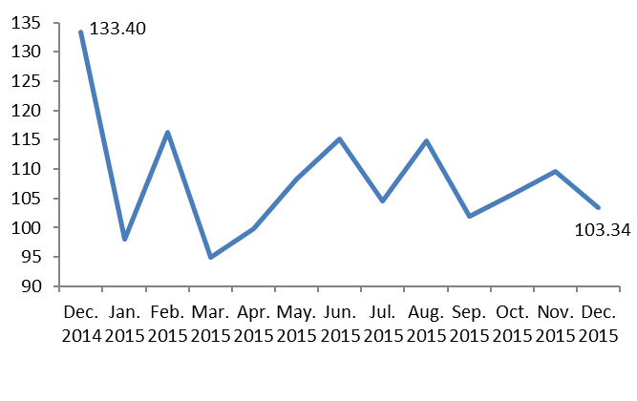

The trend line for the Industrial Production Index in Palestine for 2011 – 2015
(Base Year 2011=100)

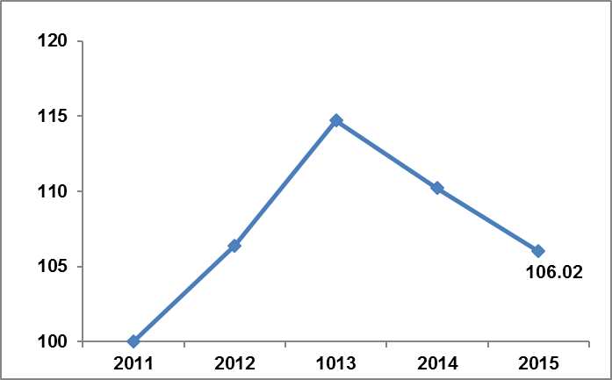

Note:
Relative share for the main industrial activities represents the percentage distribution of value added (VA) for the industrial activities in 2009.

