Palestinian Central Bureau of Statistics (PCBS)

Index of Quantity of Industrial Production in Palestine During 2013

The overall Quantity of Industrial Production Index (IPI) in Palestine reached 114.71 during the year of 2013 with an increase of 7.80% compared to the previous year of 2012 (base year 2011=100).

Quantity of Industrial Production Index increased due to the increase in the activity of Manufacturing Industry by 8.15%, Water and Electricity Supply by 7.05%, and the activity of Mining and Quarrying by 5.52%.

Index of Quantity of Industrial Production in Palestine during December 2013

The overall Quantity of Industrial Production Index (IPI) in Palestine reached 98.29 during December 2013 with a decrease of 2.11% compared to the previous month (November 2013).

Quantity of Industrial Production Index for December 2013 decreased due to the decrease in the activity of Mining and Quarrying by 29.70% which had a share of 4.59% of the total industry. Also, the activity of Manufacturing Industry decreased by 8.47% which had a share of 80.56% of the total industry. While, Water and Electricity Supply increased by 67.81% which had a share of 14.85% from the total industry.
Industrial Production Index December 2012 – December 2013 (Base Year 2011 = 100)
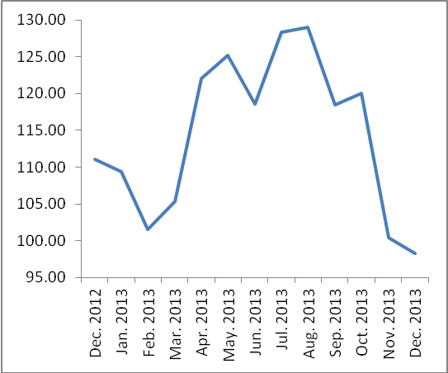
Note: Relative share for the main industrial activities represents the percentage distribution of value added (VA) for the industrial institutions in 2009.

Data collection of Industrial Production Index (IPI) survey was funded by the European Union.

