Palestinian Central Bureau of Statistics (PCBS)

Index of Quantity of Industrial Production in Palestine in January 2013

The overall Quantity of Industrial Production Index (IPI) in Palestine reached 116.09 during January 2013 (base month January 2011=100) with an increase of 1.49% compared to the previous month ( December 2012).

Quantity of Industrial Production Index for January 2013 increased due to an increase in water supply and electricity industry by 37.90% compared to the previous month which had a share of 14.85% of the total industry. While mining and quarrying industry decreased by 14.43% during January 2013 compared to the previous month which formed a share of 4.59% of the total industry. Also, manufacturing industry decreased by 5.24% compared to the previous month, which had a share of 80.56% from the total industry.

Industrial Production Index December 2011 - January 2013
(Base month January 2011 = 100)
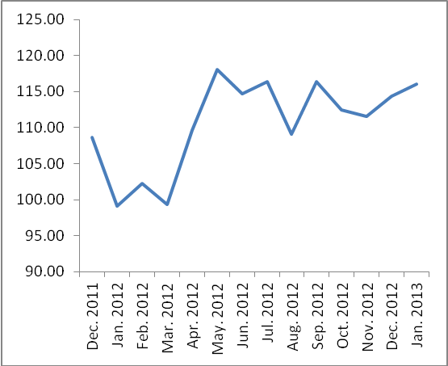

Note: Relative share for the main industrial activities represents the percentage distribution of value added (VA) for the industrial institutions in 2009.

