Palestinian Central Bureau of Statistics (PCBS)

Index of Quantity of Industrial Production in Palestine during

November, 11/2014

The overall Quantity of Industrial Production Index (IPI) in Palestine reached 109.95 during November 2014 with an increase of 4.55% compared to the previous month (Base Year 2011 = 100).

Quantity of Industrial Production Index for November 2014 increased due to the increase in the activity of Water and Electricity Supply by 64.64% which had a share of 14.85% of the total industry. Also, Mining and Quarrying increased by 14.35% which had a share of 4.59% of the total industry. While, Manufacturing industry decreased by 3.38% which had a share of 80.56% of the total industry.

Industrial Production Index November 2013 – November 2014
(Base Year 2011 = 100)
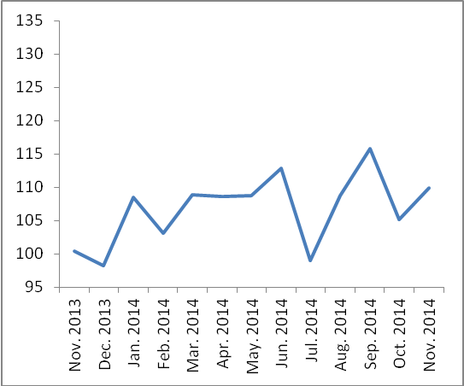

Note:
Relative share for the main industrial activities represents the percentage distribution of value added (VA) for the industrial activities in 2009.

Data collection of Industrial Production Index (IPI) survey was funded by the European Union.

