Palestinian Central Bureau of Statistics (PCBS)

Index of Quantity of Industrial Production in the Palestinian Territory, November 2012

The overall Quantity of Industrial Production Index (IPI) in the Palestinian Territory reached 111.57 in November 2012 (base month January 2011=100) with a decrease of 0.76% compared to the previous month (October 2012).

Quantity of Industrial Production Index for November 2012 decreased due to the decrease in the manufacturing industry by 1.26% compared to the previous month, which has a share of 80.56% from the total industry. While mining and quarrying industry increased by 3.06% during November 2012 compared to the previous month which forms a share of 4.59% of the total industry, and water supply and electricity industry increased by 0.51% compared to the previous month which has a share of 14.85% of the total industry.
Industrial Production Index October 2011 - November 2012
(Base month January 2011 = 100)
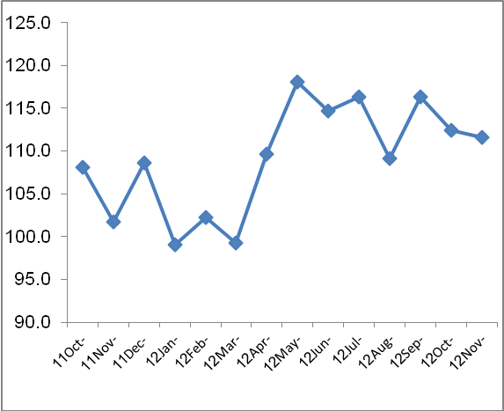

Note: Relative share for the main industrial activities represents the percentage distribution of value added (VA) for the industrial institutions in 2009.

