Palestinian Central Bureau of Statistics (PCBS)

Index of Quantity of Industrial Production in Palestine during

October, 10/2014

The overall Quantity of Industrial Production Index (IPI) in Palestine reached 105.16 during October 2014 with a decrease of 9.16% compared to the previous month (Base Year 2011 = 100).

Quantity of Industrial Production Index for October 2014 decreased due to the decrease in the activity of Mining and Quarrying by 20.18% which had a share of 4.59% of the total industry, Manufacturing industry by 8.63% which had a share of 80.56% of the total industry. Also, Water and Electricity Supply decreased by 6.97% which had a share of 14.85% of the total industry.

Industrial Production Index
October 2013 – October 2014 (Base Year 2011 = 100)
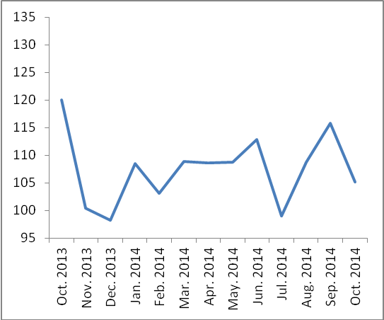

Note:
Relative share for the main industrial activities represents the percentage distribution of value added (VA) for the industrial activities in 2009.

Data collection of Industrial Production Index (IPI) survey was funded by the European Union.

