Palestinian Central Bureau of Statistics (PCBS)

Index of Quantity of Industrial Production in Palestine during October, 10/2013

The overall Quantity of Industrial Production Index (IPI) in Palestine reached 119.98 during October 2013 (base year 2011=100) with an increase of 1.32% compared to the previous month (September 2013).
Quantity of Industrial Production Index for October 2013 increased due to the increase in the activity of Mining and Quarrying by 4.15% which had a share of 4.59% of the total industry. Also, the activity of Manufacturing Industry increased by 3.21% which had a share of 80.56% of the total industry. While, Water and Electricity Supply which had a share of 14.85% from the total industry decreased by 7.59% during October 2013 compared to the previous month.

Industrial Production Index October 2012 – October 2013
(Base Year 2011 = 100)

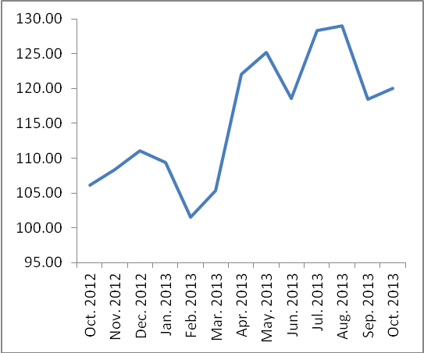

Note: Relative share for the main industrial activities represents the percentage distribution of value added (VA) for the industrial institutions in 2009.

