Palestinian Central Bureau of Statistics (PCBS)

Index of Quantity of Industrial Production in Palestine during

September, 09/2015

The overall Quantity of Industrial Production Index (IPI) in Palestine reached 101.97 during September 2015 with a sharp decrease of 11.19% compared with the previous month (Base Year 2011 = 100).

Quantity of Industrial Production Index for September 2015 decreased due to the decrease in the activity of Manufacturing industry by 12.80% which had a share of 80.56% of the total industry, the activity of Mining and Quarrying by 9.32% which had a share of 4.59% of the total industry, also, Water and Electricity Supply decreased by 5.26% which had a share of 14.85% of the total industry.

Industrial Production Index September 2014 – September 2015
(Base Year 2011 = 100)
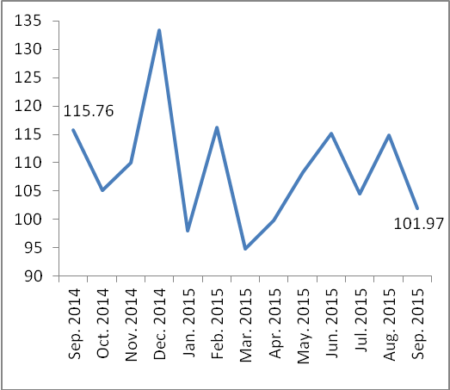

Note:
Relative share for the main industrial activities represents the percentage distribution of value added (VA) for the industrial activities in 2009.

