Palestinian Central Bureau of Statistics (PCBS)

Index of Quantity of Industrial Production in Palestine during September 2013

The overall Quantity of Industrial Production Index (IPI) in Palestine reached 118.42 during September 2013 (base year 2011=100) with a decrease of 8.25% compared to the previous month ( August 2013).

Quantity of Industrial Production Index for September 2013 decreased due to the decrease in the activity of Manufacturing Industry by 10.01% which had a share of 80.56% of the total industry. Also, Water and Electricity Supply which had a share of 14.85% from the total industry decreased by 8.12% during September 2013 compared to the previous month. While, the activity of Mining and Quarrying which had a share of 4.59% of the total industry increased by 18.80% during September 2013 compared to the previous month.
Industrial Production Index
September 2012 – September 2013 (Base Year 2011 = 100)
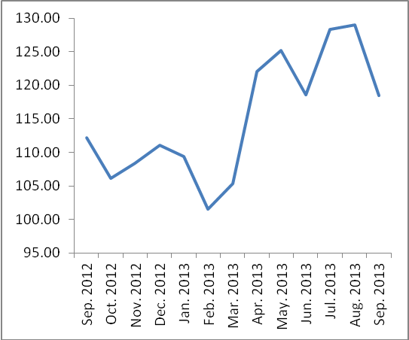

Note: Relative share for the main industrial activities represents the percentage distribution of value added (VA) for the industrial institutions in 2009.

