Palestinian Central Bureau of Statistic (PCBS)

Index of Quantity of Industrial Production in the Palestinian Territory, September 2012

The overall Quantity of Industrial Production Index (IPI) in the Palestinian Territory reached 116.36 in September 2012 (base month January 2011=100) with an increase of 6.66% compared to the previous month (August 2012).

Quantity of Industrial Production Index for September 2012 increased due to the increase in the manufacturing industry by 12.03% compared to the previous month, which has a share of 80.56% from the total industry. And mining and quarrying industry increased by 11.23% during September 2012 compared to the previous month which forms a share of 4.59% of the total industry, while water supply and electricity industry decreased by 10.62% compared to the previous month which has a share of 14.85% of the total industry.

Industrial Production Index August 2011 - September 2012 (Base month January 2011 = 100)
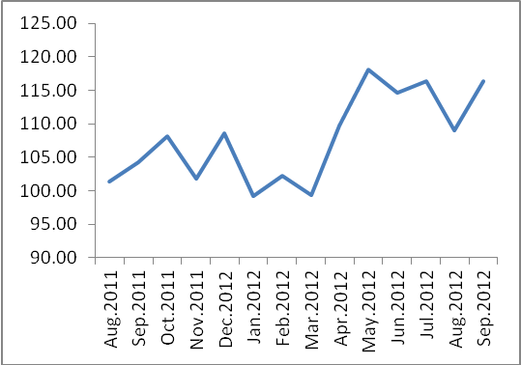

Note: Relative share for the main industrial activities represents the percentage distribution of value added (VA) for the industrial institutions in 2009.

