Palestinian Central Bureau of Statistics (PCBS)

Index of Quantity of Industrial Production in Palestine during August 2013

The overall Quantity of Industrial Production Index (IPI) in Palestine reached 129.06 during August 2013 (base year 2011=100) with an increase of 0.55% compared to the previous month ( July 2013).

Quantity of Industrial Production Index for August 2013 increased due to the increase in the activity of manufacturing industry by 4.59% which had a share of 80.56% of the total industry. While, the activity of mining and quarrying which had a share of 4.59% of the total industry deceased by 16.43% during August 2013 compared to the previous month. Also, the water and electricity supply industry which had a share of 14.85% from the total industry decreased by 9.34% during August 2013 compared to the previous month.

Industrial Production Index August 2012 – August 2013
(Base Year 2011 = 100)
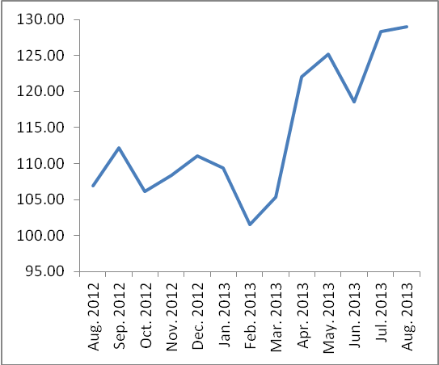

Note: Relative share for the main industrial activities represents the percentage distribution of value added (VA) for the industrial institutions in 2009.

