Palestinian Central Bureau of Statistics (PCBS)

Index of Quantity of Industrial Production in the Palestinian Territory, August 2012

The overall Quantity of Industrial Production Index (IPI) in the Palestinian Territory reached 109.09 in August 2012 (base month January 2011=100) with a decrease of 6.25% compared to the previous month (July 2012).

Quantity of Industrial Production Index for August 2012 decreased due to the decrease in the manufacturing industry by 13.68% compared to the previous month, which has a share of 80.56% from the total industry. Meanwhile mining and quarrying industry decreased by 5.88% during August 2012 compared to the previous month which forms a share of 4.59% of the total industry, while water supply and electricity industry increased by 27.01% compared to the previous month which has a share of 14.85% of the total industry.
Industrial Production Index July 2011 - August 2012
(Base month January 2011 = 100)
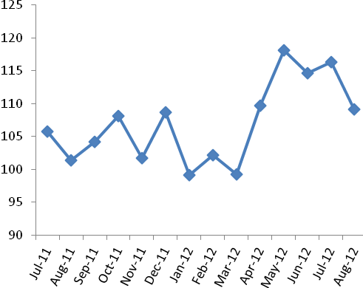

Note: Relative share for the main industrial activities represents the percentage distribution of value added (VA) for the industrial institutions in 2009.

