Palestinian Central Bureau of Statistics (PCBS)

Index of Quantity of Industrial Production in Palestine during

July, 07/2015

The overall Quantity of Industrial Production Index (IPI) in Palestine reached 104.48 during July 2015 with a decrease of 9.27% compared with the previous month (Base Year 2011 = 100).

Quantity of Industrial Production Index for July 2015 decreased due to the decrease in the activity of Manufacturing industry by 12.25% which had a share of 80.56% of the total industry, the activity of Mining and Quarrying decreased by 0.56% which had a share of 4.59% of the total industry. While, Water and Electricity Supply increased by 1.87% which had a share of 14.85% of the total industry..

Industrial Production Index July 2014 – July 2015
(Base Year 2011 = 100)
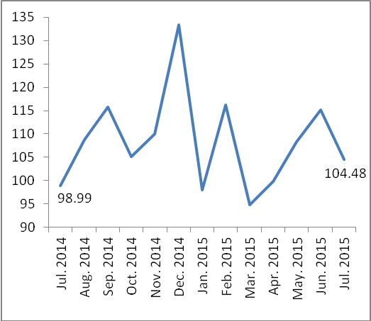

Note:
Relative share for the main industrial activities represents the percentage distribution of value added (VA) for the industrial activities in 2009.

Data collection of Industrial Production Index (IPI) survey was funded by the European Union.

