Palestinian Central Bureau of Statistics (PCBS)

Index of Quantity of Industrial Production in Palestine during

July, 07/2014

The overall Quantity of Industrial Production Index (IPI) in Palestine reached 98.99 during July 2014 with a decrease of 12.24% compared to the previous month (June 2014).

Quantity of Industrial Production Index for July 2014 decreased due to the decrease in Manufacturing by 15.88% which had a share of 80.56% of the total industry. Also, Water and Electricity Supply industry decreased by 3.57% which had a share of 14.85% of the total industry. While, the activity of Mining and Quarrying increased by 5.09% which had a share of 4.59% of the total industry.

Industrial Production Index July 2013 – July 2014
(Base Year 2011 = 100)
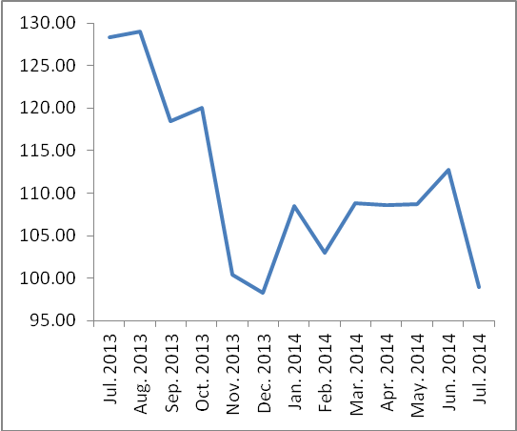

Note:
- Relative share for the main industrial activities represents the percentage distribution of value added (VA) for the industrial activities in 2009.
- Data of the most important industrial establishments in Gaza Strip was indirectly collected from the field due to Israeli aggression during July 2014.

Data collection of Industrial Production Index (IPI) survey was funded by the European Union.

