Palestinian Central Bureau of Statistics (PCBS)

Index of Quantity of Industrial Production in Palestine during July 2013

The overall Quantity of Industrial Production Index (IPI) in Palestine reached 128.35 during July 2013 (base year 2011=100) with an increase of 8.26% compared to the previous month ( June 2013).

Quantity of Industrial Production Index for July 2013 increased due to the increase in the water and electricity supply industry by 23.25% which had a share of 14.85% of the total industry. Also, the manufacturing industry which had a share of 80.56% from the total industry increased by 6.00% during July 2013 compared to June 2013. While, the activity of mining and quarrying which had a share of 4.59% of the total industry deceased by 5.35% during July 2013 compared to the previous month.

Industrial Production Index July 2012 – July 2013 (Base Year 2011 = 100)
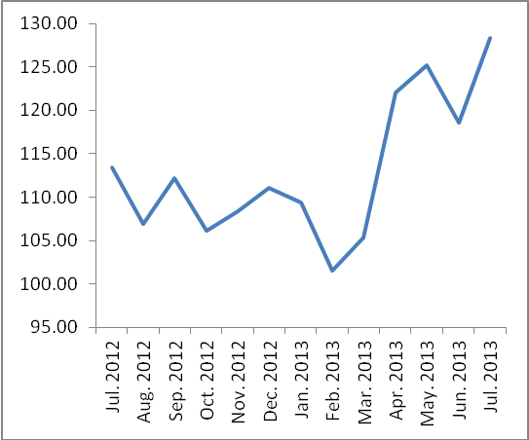

Note: Relative share for the main industrial activities represents the percentage distribution of value added (VA) for the industrial institutions in 2009.

