Palestinian Central Bureau of Statistics (PCBS)

Index of Quantity of Industrial Production in the Palestinian Territory, July 2012

The overall Quantity of Industrial Production Index (IPI) in the Palestinian Territory reached 116.36 in July 2012 (base month January 2011=100) with an increase of 1.46% compared to the previous month (June 2012).

Quantity of Industrial Production Index for July 2012 increased due to the increase in the manufacturing industry by 3.50% compared to the previous month, which has a share of 80.56% from the total industry. While water supply and electricity industry decreased by 6.27% compared to the previous month which has a share of 14.85% of the total industry, and mining and quarrying industry decreased by 0.85% during July 2012 compared to the previous month which forms a share of 4.59% of the total industry.

Industrial Production Index June 2011 - July 2012
(Base month January 2011 = 100)
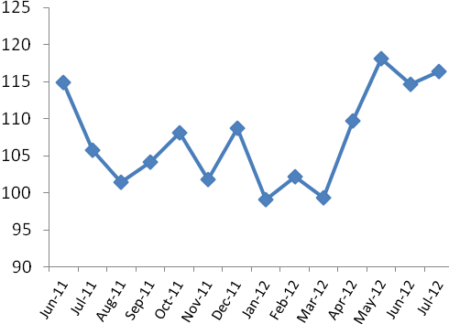

Note: Relative share for the main industrial activities represents the percentage distribution of value added (VA) for the industrial institutions in 2009.

