Palestinian Central Bureau of Statistics (PCBS)

Index of Quantity of Industrial Production in Palestine during June, 06/2013

The overall Quantity of Industrial Production Index (IPI) in Palestine reached 118.56 during June 2013 (base year 2011=100) with a decrease of 5.32% compared to the previous month ( May 2013).

Quantity of Industrial Production Index for June 2013 decreased due to the decrease in the manufacturing industry by 9.17% compared to May 2013, which had a share of 80.56% from the total industry. While water and electricity supply industry which had a share of 14.85% of the total industry increased by 11.90% compared to the previous month. Also, the activity of mining and quarrying increased by 2.18% during June 2013 compared to the previous month which had a share of 4.59% of the total industry.
Industrial Production Index June 2012 – June 2013
(Base Year 2011 = 100)
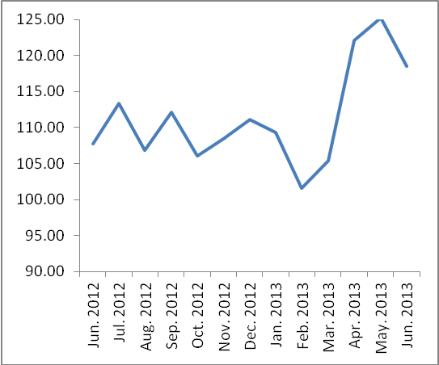

Note: Relative share for the main industrial activities represents the percentage distribution of value added (VA) for the industrial institutions in 2009.

