Palestinian Central Bureau of Statistics (PCBS)

Index of Quantity of Industrial Production in Palestine during May,05/ 2014

The overall Quantity of Industrial Production Index (IPI) in Palestine reached 108.76 during May 2014 with an increase of 0.13% compared to the previous month (April 2014).

Quantity of Industrial Production Index for May 2014 increased due to the increase in Water and Electricity Supply by 6.89% which had a share of 14.85% of the total industry. As well as, the activity of Mining and Quarrying increased by 2.41% which had a share of 4.59% of the total industry. While, Manufacturing industry decreased by 1.85% which had a share of 80.56% of the total industry.
Industrial Production Index May 2013 – May 2014
(Base Year 2011 = 100)
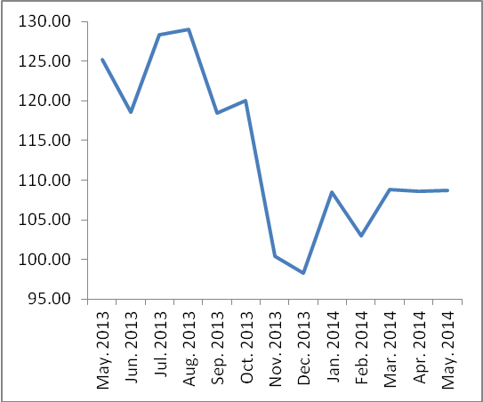

Note: Relative share for the main industrial activities represents the percentage distribution of value added (VA) for the industrial activities in 2009.

Data collection of Industrial Production Index (IPI) survey was funded by the European Union.

