Palestinian Central Bureau of Statistics (PCBS)

Index of Quantity of Industrial Production in Palestine during May 2013

The overall Quantity of Industrial Production Index (IPI) in Palestine reached 125.22 during May 2013 (base year 2011=100) with an increase of 2.60% compared to the previous month ( April 2013).

Quantity of Industrial Production Index for May 2013 increased due to the increase in the activity of mining and quarrying by 21.29% during May 2013 compared to the previous month which formed a share of 4.59% of the total industry. Also, water and electricity supply industry which had a share of 14.85% of the total industry increased by 4.24% compared to the previous month. Also, the manufacturing industry increased by 1.06% compared to the previous month, which had a share of 80.56% from the total industry
Industrial Production Index, May 2012 – May 2013
(Base Year 2011 = 100)
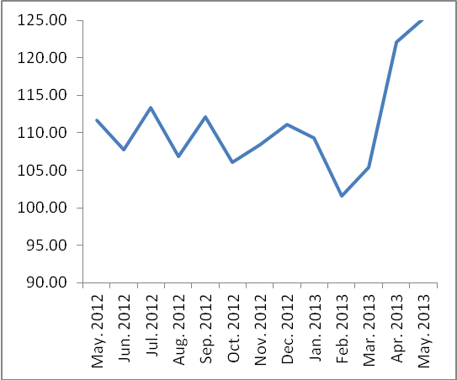

Note: Relative share for the main industrial activities represents the percentage distribution of value added (VA) for the industrial institutions in 2009.

