Index of Quantity of Industrial Production in Palestine during

April 2015

The overall Quantity of Industrial Production Index (IPI) in Palestine reached 99.82 during April 2015 with an increase of 5.23% compared to the previous month (Base Year 2011 = 100).

Quantity of Industrial Production Index for April 2015 increased due to the increase in the activity of Water and Electricity Supply by 34.66% which had a share of 14.85% of the total industry, Mining and Quarrying increased by 11.36% which had a share of 4.59% of the total industry. While, the activity of Manufacturing industry decreased by 0.20% which had a share of 80.56% of the total industry.

Industrial Production Index
April 2014 – April 2015
(Base Year 2011 = 100)
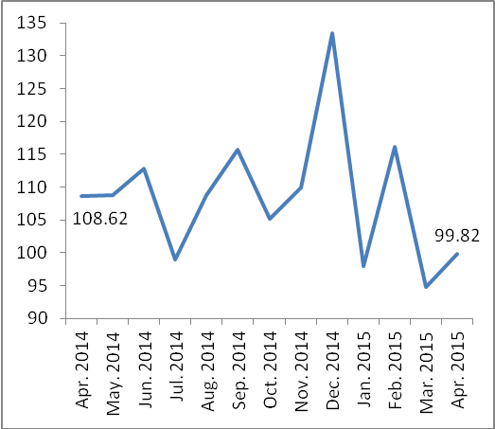

Note:
Relative share for the main industrial activities represents the percentage distribution of value added (VA) for the industrial activities in 2009.

For more information, please contact:
Palestinian Central Bureau of Statistics
Ramallah, Palestine.
Tel: (972/970) 2 2982700
Fax: ( 972/970) 2 2982710
Toll free.: 1800300300
E-Mail: diwan@pcbs.gov.ps
Web-Site: http://www.pcbs.gov.ps

Data collection of Industrial Production Index (IPI) survey was funded by the European Union.

