Palestinian Central Bureau of Statistics (PCBS)

Index of Quantity of Industrial Production in Palestine during April, 04/2014

The overall Quantity of Industrial Production Index (IPI) in Palestine reached 108.62 during April 2014 with a decrease of 0.19% compared to the previous month (March 2014).

Quantity of Industrial Production Index for April 2014 decreased due to the decrease of Water and Electricity Supply by 4.43% which had a share of 14.85% of the total industry. While, the activity of Mining and Quarrying increased by 6.15% which had a share of 4.59% of the total industry. As well as, the Manufacturing industry increased by 0.53% which had a share of 80.56% of the total industry.

Industrial Production Index April 2013 – April 2014
(Base Year 2011 = 100)
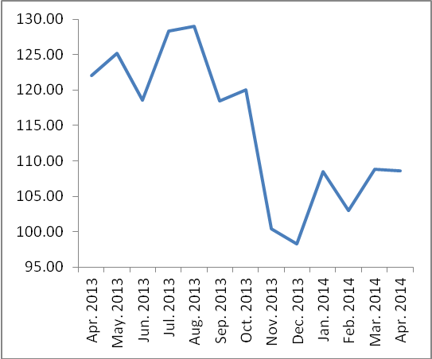

Note: Relative share for the main industrial activities represents the percentage distribution of value added (VA) for the industrial activities in 2009.

Data collection of Industrial Production Index (IPI) survey was funded by the European Union.

