Palestinian Central Bureau of Statistics (PCBS)

Index of Quantity of Industrial Production in Palestine during April, 2013

The overall Quantity of Industrial Production Index (IPI) in Palestine reached 125.48 during April 2013 (base month January 2011=100) with an increase of 15.20% compared to the previous month ( March 2013).

Quantity of Industrial Production Index for April 2013 increased due to the increase in the manufacturing industry by 20.09% compared to the previous month, which had a share of 80.56% from the total industry. Also, mining and quarrying increased by 7.85% during April 2013 compared to the previous month which formed a share of 4.59% of the total industry. While, water and electricity supply industry which had a share of 14.85% of the total industry decreased by 2.74% compared to the previous month.

Industrial Production Index April 2012 – April 2013
(Base month January 2011 = 100)
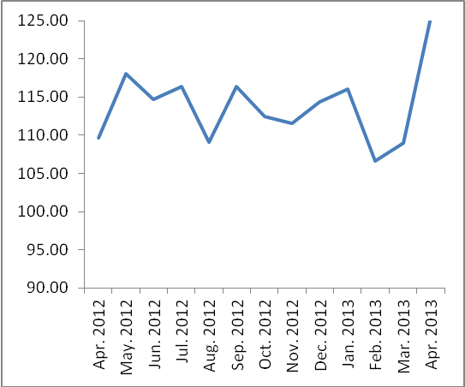

Note: Relative share for the main industrial activities represents the percentage distribution of value added (VA) for the industrial institutions in 2009.

