Palestinian Central Bureau of Statistics (PCBS)

Decrease in the Industrial Production in Palestine during March, 03/2016

Decrease in the Industrial Production Index in Palestine during March 2016
The overall Quantity of Industrial Production Index (IPI) in Palestine reached 101.87 during March 2016 with a decrease of 1.30% compared to the previous month (Base Month December 2015 = 100).

Quantity of Industrial Production Index for March 2016 decreased due to the decrease in the activity of Electricity, Gas, Steam and Air Conditioning Supply by 8.06% which had a share of 11.98% of the total industry, activity of Mining and Quarrying by 2.80% which had a share of 4.06% of the total industry, and the activity of Manufacturing Industry decreased by 0.48% which had a share of 83.19% of the total industry, while the activity of Water Supply, Sewerage, Waste Management and Remediation Activities increased by 2.83% which had a share of 0.78% of the total industry.

The Industrial Production Index in Palestine, for the period:
March 2015 - March 2016
(Base Month December 2015=100)

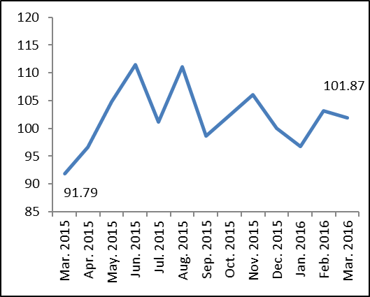

Note:
- Since the beginning of 2016, PCBS updated the base month for the Quantity of Industrial Production to be December 2015 instead of 2011, as well as started using International Standard of Industrial Classification for all Economic Activates (Revision Four) instead of Revision Three.
- Relative share for the main industrial activities represents the percentage distribution of value added (VA) for the industrial activities in 2013.

