Palestinian Central Bureau of Statistics (PCBS)

Index of Quantity of Industrial Production in Palestine during March 2013

The overall Quantity of Industrial Production Index (IPI) in Palestine reached 108.92 during March 2013 (base month January 2011=100) with an increase of 2.13% compared to the previous month ( January 2013).

Quantity of Industrial Production Index for March 2013 increased due to the increase in the mining and quarrying by 37.35% during March 2013 compared to the previous month which formed a share of 4.59% of the total industry. Also, the manufacturing industry increased by 2.30% compared to the previous month, which had a share of 80.56% from the total industry. While the water and electricity supply industry which had a share of 14.85% of the total industry decreased by 4.78% compared to the previous month.

Industrial Production Index February 2012 – March 2013
(Base month January 2011 = 100)
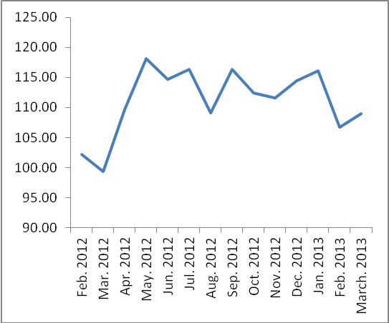

Note: Relative share for the main industrial activities represents the percentage distribution of value added (VA) for the industrial institutions in 2009.

