Palestinian Central Bureau of Statistics (PCBS)

Index of Quantity of Industrial Production in Palestine during

February, 02/2015

The overall Quantity of Industrial Production Index (IPI) in Palestine reached 116.21 during February 2015 with an increase of 18.59% compared to the previous month (Base Year 2011 = 100).

Quantity of Industrial Production Index for February 2015 increased due to the increase in the activity of Manufacturing industry by 26.64% which had a share of 80.56% of the total industry. And the activity of Mining and Quarrying increased by 0.66% which had a share of 4.59% of the total industry, while Water and Electricity Supply decreased by 2.72% which had a share of 14.85% of the total industry.

Industrial Production Index February 2014 – February 2015
(Base Year 2011 = 100)
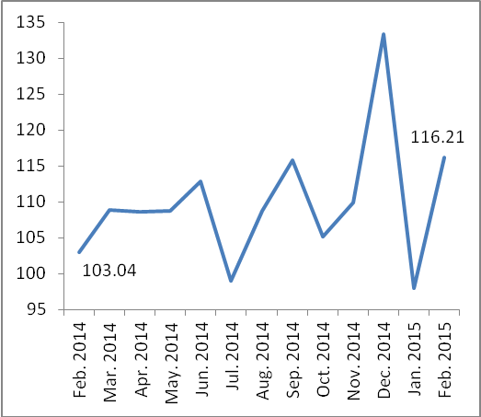
Note:
Relative share for the main industrial activities represents the percentage distribution of value added (VA) for the industrial activities in 2009.

Data collection of Industrial Production Index (IPI) survey was funded by the European Union.

