Palestinian Central Bureau of Statistics (PCBS)

Index of Quantity of Industrial Production in Palestine during February 2014

The overall Quantity of Industrial Production Index (IPI) in Palestine reached 103.04 during February 2014 with a decrease of 5.06% compared to the previous month (January 2014).

Quantity of Industrial Production Index for February 2014 decreased due to the decrease in the activity of Mining and Quarrying by 16.59% which had a share of 4.59% of the total industry. And Water and Electricity Supply decreased by 11.26% which had a share of 14.85% of the total industry. Also, the activity of Manufacturing Industry decreased by 1.84% which had a share of 80.56% of the total industry.

Industrial Production Index February 2013 – February 2014
(Base Year 2011 = 100)
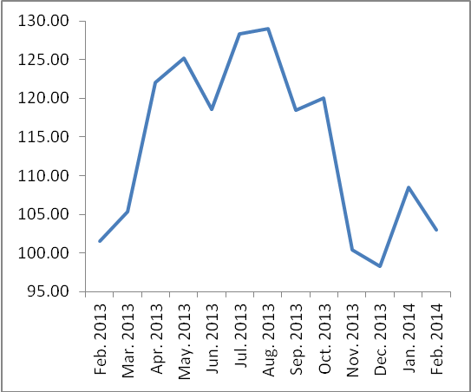

Note: Relative share for the main industrial activities represents the percentage distribution of value added (VA) for the industrial activities in 2009.

Data collection of Industrial Production Index (IPI) survey was funded by the European Union.

