Palestinian Central Bureau of Statistics (PCBS)

Index of Quantity of Industrial Production in Palestine in February 2013

The overall Quantity of Industrial Production Index (IPI) in Palestine reached 106.66 during February 2013 (base month January 2011=100) with a decrease of 8.13% compared to the previous month

(January 2013).

Quantity of Industrial Production Index for February 2013 decreased due to a decrease in the water and electricity supply industry by 16.72% compared to the previous month which had a share of 14.85% of the total industry. Also, the manufacturing industry decreased by 5.98% compared to the previous month, which had a share of 80.56% from the total industry. While mining and quarrying industry increased by 1.59% during February 2013 compared to the previous month which formed a share of 4.59% of the total industry.

Industrial Production Index January 2012 – February 2013
(Base month January 2011 = 100)
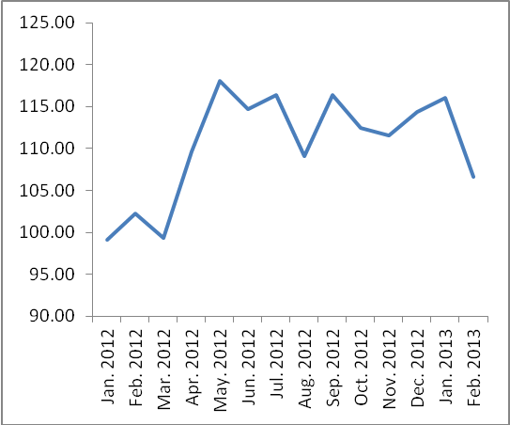

Note: Relative share for the main industrial activities represents the percentage distribution of value added (VA) for the industrial institutions in 2009.

