Palestinian Central Bureau of Statistics (PCBS)

Index of Quantity of Industrial Production in Palestine during

August, 08/2014

The overall Quantity of Industrial Production Index (IPI) in Palestine reached 108.77 during August 2014 with an increase of 9.89% compared to the previous month (Base Year 2011 = 100).

Quantity of Industrial Production Index for August 2014 increased due to the increase in Manufacturing industry by 29.50% which had a share of 80.56% of the total industry. While, Water and Electricity Supply decreased by 47.48% which had a share of 14.85% of the total industry, and the activity of Mining and Quarrying decreased by 9.17% which had a share of 4.59% of the total industry.

Industrial Production Index August 2013 – August 2014
(Base Year 2011 = 100)
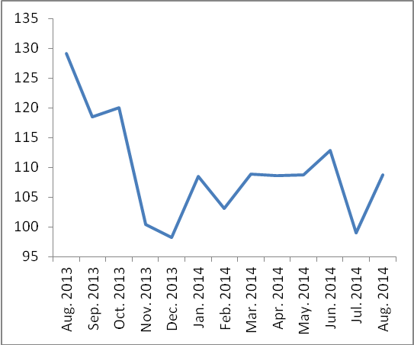

Note:
Relative share for the main industrial activities represents the percentage distribution of value added (VA) for the industrial activities in 2009.

Data collection of Industrial Production Index (IPI) survey was funded by the European Union.

