Palestinian Central Bureau of Statistics (PCBS)

Index of Quantity of Industrial Production in Palestine during

June, 06/2015

The overall Quantity of Industrial Production Index (IPI) in Palestine reached 115.15 during June 2015 with an increase of 6.30% compared with the previous month (Base Year 2011 = 100).

Quantity of Industrial Production Index for June 2015 increased due to the increase in the activity of Manufacturing industry by 8.46% which had a share of 80.56% of the total industry, Water and Electricity Supply increased by 1.17% which had a share of 14.85% of the total industry. While, the activity of Mining and Quarrying decreased by 6.79% which had a share of 4.59% of the total industry.

Industrial Production Index June 2014 – June 2015
(Base Year 2011 = 100)
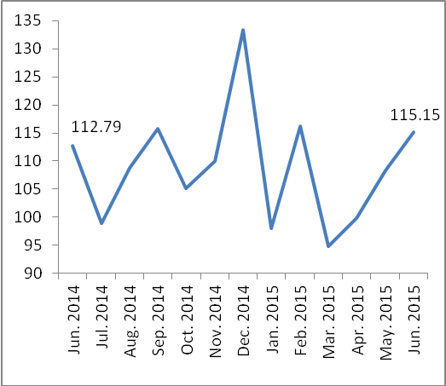

Note:
Relative share for the main industrial activities represents the percentage distribution of value added (VA) for the industrial activities in 2009.

Data collection of Industrial Production Index (IPI) survey was funded by the European Union.

