The Palestinian central Bureau of Statistics ( PCBS) and the Ministry of Communications and Information Technology issue a joint press release on the eve of the International Day for Society of Information which marks on the 17th of May.

The world celebrates the International Day for society of information for this year under a title of " Broadband and sustainable development ." The most important elements of the society of information based on knowledge are fair accessibility to information and development of human perception to its importance. Information is considered the most important portal for the Palestinian economy to connecting with global economy and overcoming restrictions imposed by Israeli military occupation .

Communications in Palestine
The number of fix telephone lines in Palestine reached 402 thousands in 2013 while the number of mobile phone subscribers reached 3.3 million. The number of ADSL subscribers reached more than 204 thousands in 2013. Currently, the number of computers in Palestine are estimated up to a half million.

About a quarter of individuals have a smart phone
Currently, it is estimated that individuals who own a smart phone reached about a quarter of the total individuals who own a mobile phone , while the percentage of household in Palestine which has computer reached (51.4 % ) in 2012, ( 55.2 % in West Bank and 44.2% in Gaza Strip), compared to a nearly of one-third ( 32.8 % ) in 2006 .

Percentage of Households with Computer by Region

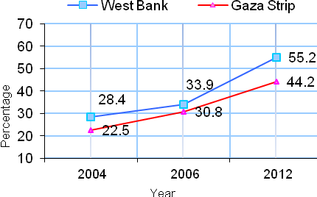

Gender gap in the use of technology
Despite the high percentage of Internet users of both gender in 2011 compared to 2000, however, the gender gap still exists. Where the percentage of Internet users among males increased from 7.9 % to 44.3% and the percentage of Internet users among females increased from 2.8 % to 34.2 %.

Percentage of Internet use by sex

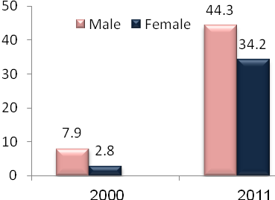

The gap clearly receded between both genders regarding the percentage of the use of mobile phones reached 37.5 % for males and 5.6 % for females in 2000, while the percentage increased to 76.5 % for males and 53.6 % for females in 2011

Percentage of Owning a Mobile Phone
by Sex

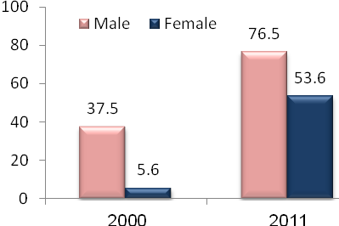

Reasons for not owning a computer
the negative perceptions among Palestinian household on importance of computers changed during the past five years in terms of spurning time or damaging health. Computers cost is still the first reason for the households for not owning a personal computer .

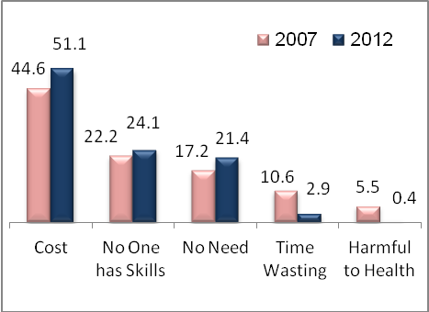

Economic establishments and information technology
Data showed a doubling percentage of computer use and availability of a Website in economic establishments during the period between 2007 and 2012. While tripling percentage of the use of the Internet, as well as the percentage of implementation of electronically commercial transactions reached 2.3 % in 2007 against to 11.2 % in 2012.
Information Technology in Economic Establishments

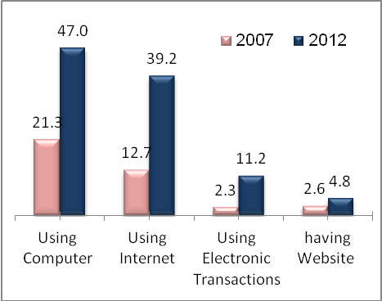

Foreign trade of informatics and communications
The gap clearly receded between exports and imports of goods and services of information technology and communications as imports became two times more than exports in 2012 , after imports were quadrupled exports in 2000, according to Foreign Trade Statistics data base .

Foreign Trade of Informatics and Communications in thousand U.S. dollars

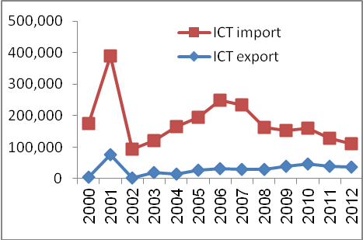

Research and development in ICT sector
The highest percentage of establishments carried out research and development work was in ICT sector , which amounted to one-third, while the percentage of economic establishments which conducted research and development in technology reached ​​2.5% of the total establishments in Palestine. This expenditure on research and development in Palestine did not exceed one percent of GDP in 2012.

