Palestinian Central Bureau of Statistics (PCBS) and the Ministry of Telecom and Information Technology issue a joint press release On the occasion of the World Telecommunication and Information Society Day 17/05/2022.

World Telecommunication and Information Society Day (WTISD) has been annually celebrated on May 17th since 1969 to mark the founding of ITU and the signing of the first International Telegraph Convention in 1865.

The theme of this year's (WTISD) is "Digital technologies for older persons and healthy ageing", calling all stakeholders to involve in contributing, and innovating throughout the year with national, regional, and international initiatives to accelerate digital technologies for older persons and healthy ageing, combat age-based discrimination at the workplace, and ensure financial inclusion of older persons.

The majority of Palestinian households have access to internet at their homes and more than two thirds of the households are headed by older persons
During the first quarter of 2022, around 91% of households stated that they have access to internet service at home or at one of their household members (91% in the West Bank and 90% in the Gaza Strip).

Moreover, data showed that 77% of households headed by older persons (60 years and above) have access to internet service or at the home of one of their household members (78% in the West Bank and 77% in the Gaza Strip).

More than half of the older persons use the internet
The percentage of individuals (10 years and above) who used the internet from anywhere reached 88% in Palestine (91% in the West Bank and 83% in the Gaza Strip).

Moreover, the percentage of the elderly who used the internet from anywhere was 53% (57% in the West Bank and 44% in the Gaza Strip). (57% for males and 49% for females).

More than two thirds of older persons own at least one cellular phone in Palestine
The percentage of individuals (10 years and above) who own a cellular phone is 78% (85% in the West Bank and 68% in the Gaza Strip). Meanwhile, 77% of the elderly own a cellular phone (81% in the West Bank and 70% in the Gaza Strip). (87% for males and 69% for females.

The vast majority of individuals in Palestine own smartphones. Half of them are older persons.
The percentage of individuals (10 years and above) who own a smartphone is 71% (82% in the West Bank and 56% in the Gaza Strip). Meanwhile, 50% of the elderly own at least one smartphone (58% in the West Bank and 35% in the Gaza Strip) (52% for males and 48% for females).
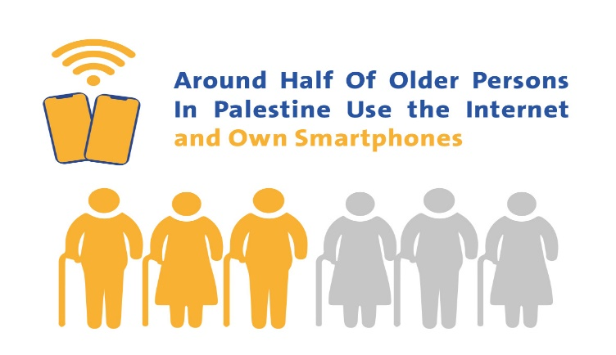

More than 4 Million active cellular phone subscriptions
Data from the Ministry of Telecom and Information Technology indicated that there has been an expansion in the fixed network infrastructure, accompanied by increased use by households and institutions of this network and related services, especially the internet service. The number of landlines in Palestine reached 485,829 telephone lines (Home, Commercial, Governmental) at the end of 2021 compared with 360,402 lines at the end of 2010, with an increase of 35%.

Total Number of Fixed and Active Cellular Phone Lines in Palestine during 2010-2021
(Thousands)

Meanwhile, there was an increase in the active cellular phone subscriptions in Palestine by the end of 2021 reaching around 4.1 million subscribers compared to 2.6 million at the end of 2010, with an increase of 56%.

A huge increase in the number of ADSL subscribers
The total number of ADSL subscribers in Palestine increased to about 405 thousand subscribers by the end of 2021 compared with 119 thousand subscribers by the end of 2010, with an increase of 240%. The average internet speed was 13.5 Mbps at the end of 2021 compared with 0.5 Mbps at the end of 2010.

Total Number of ADSL Subscribers in Palestine, 2010-2021 (Thousands)

The Ministry of Telecom and Information Technology, in cooperation with companies operating in the sector, has decided to present special offers for the elderly entitled "World Telecommunication Day 2022 offers", which would increase the technological inclusion of this category, including facilitating access; and creating solutions to the issues the elderly are facing while using technology. The Ministry supports initiatives that support digital inclusion, including digital technologies for the elderly through workshops aimed at bridging the digital gap, promoting digital inclusion for the elderly, and analyzing the effects of the gap on their digital inclusion.

Using digital solutions in establishments to mitigate the effect of the COVID-19 Pandemic
There was a decrease in sales/production size of information and communication sector during COVID-19 pandemic (5/3/2021–31/5/2021). Establishments reported a decrease by 47% compared to the normal situation. Meanwhile, 18% of the establishments started using or have increased the use of internet, online social media networks, specialized apps or digital platforms in response to COVID-19 outbreak. The main use of such digital solutions was for marketing with a percentage of 83%, 53% for business administration and 38% for selling.

During three months (88 days), starting from March 5th until May 31st, 2021, establishments reported that the percentage of employees who were working remotely from home was 8% out of the total number of employees; mainly in the telecommunication activities (12% of the total number of employees) and transportation activities (8% of the total number of employees). The main results also showed that the highest percentage of employees who were working remotely from home was among large establishments comprising (18%).

Data excluded those parts of Jerusalem that were annexed by Israeli occupation in 1967.

