Palestinian Central Bureau of Statistics (PCBS)

Press Release on Results of Household Energy Survey (January 2015).

85% of Households in the North of West Bank Used a Prepaid Electricity Meter

99.9% of households in Palestine were connected to the public electricity network in January 2015, compared to 99.3% in the same period of 2009.

58% of households in Palestine used a normal Electricity Meter; while 42% of households used a Prepaid Electricity Meter as of January 2015.

Region | Type of Electricity Meter Used
Region | Normal Meter | Prepaid Meter | Total
Palestine | 58.3 | 41.7 | 100
West Bank | 38.2 | 61.8 | 100
North of West Bank | 14.6 | 85.4 | 100
Middle of West Bank | 69.4 | 30.6 | 100
South of West Bank | 39.1 | 60.9 | 100
Gaza Strip | 96.9 | 3.1 | 100

More Than Half of Households Have Solar Heater System
57% of households in Palestine had solar energy heaters in January 2015, showing a decrease from its level at 60% in January 2009.

Average of Household’s Consumption of Electricity was 306 KWh
The average of household consumption of electricity (among those households using electricity) in Palestine was 306 KWh in January 2015 compared to 275 KWh in January 2009.

Average of Households’ Consumption of Electricity, January 2015 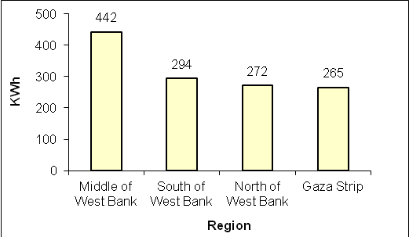

The Highest Average of Gasoline Consumption is Concentrated in the Middle of West Bank
The average of household consumption of gasoline (among those households using gasoline) in Palestine was 95 liters in January 2015. It was 135 liters in the Middle of West Bank but didn't exceed 42 liters in Gaza Strip.

High Average of Gas Consumption
The average of household consumption of liquefied petroleum gas (among those households using liquefied petroleum gas) in Palestine was 22 kg in January 2015 compared to 21 Kg in January 2009.

Most Households Depended on Electricity for Water Heating
60% of households which heated water in Palestine used electricity, as a main source for water heating, 28% of households depended on liquefied petroleum gas, while 9% used wood, and 3% of households depended on solar energy heaters for heating water in January 2015.

41% of Households in Gaza Strip didn't Heat their Houses in Cold Season
18% of the households in Palestine didn't heat their houses, with 41% in Gaza Strip and 6% in the West Bank. For Households which heated their houses, the results showed that 39% of them depended on electricity as a main source for heating, 29% depended on wood, while 25% of households depended on liquefied petroleum gas, and 1% of households depend on kerosene as a main source for heating.

