Palestinian Central Bureau of Statistics (PCBS)

Press Release on Household Environmental Survey,2015
Household Sector Consumed about 16 million cubic meters of water per month
The household sector in Palestine consumed about 16.323 million cubic meters of water per month (MCM/month) during the year 2015 as follows: 10.460 MCM/month in the West Bank and 5.863 MCM/month in Gaza Strip. The monthly average household consumption of water in Palestine was 18.7 cubic meters (M³): 18.3 M³ in the West Bank and 19.7 M³ in Gaza Strip.

93% of Households in Palestine were connected to Water Networks
The percentage of households living in a housing unit connected to a water network was 93.3% in 2015 compared to 96.4% in 2013.

Percentage of Households in Palestine whom Living in Housing Units Connected to Public Water Network and Region, 2015

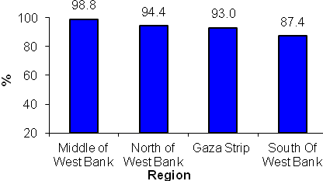

Connection to Wastewater Networks
During 2015, data indicated that 53.9% of households in Palestine used wastewater networks to dispose of their wastewater.

Local Authorities are responsible for Solid Waste Collection Services
Local authorities collected solid waste for 78.8% of households in Palestine, UNRWA collected 9.4% of solid waste, and for 0.3% of households a special contractor collected the solid waste.

Average Daily Household Solid Waste Generation
The average daily generation of household waste in Palestine in 2015 was estimated at 2.9 kg: around 3.2 kg in the West Bank and 2.4 kg in Gaza Strip. The overall quantity of solid waste generated daily was about 2,551.0 tons in 2015.

Quantity of Solid Waste Generated Daily and Average Daily Household Generation of Solid Waste in Palestine by Region, 2015

Region | Total daily generated quantity (Ton) | Average household daily generation (Kg)
Palestine | 2,551.0 | 2.9
West Bank | 1,835.0 | 3.2
North of West Bank | 711.5 | 3.2
Middle of West Bank | 563.5 | 3.4
South of West Bank | 560.0 | 3.0
Gaza Strip | 716.0 | 2.4

Exposure to Noise and Smells

Around 19.8% of households in Palestine were exposed to noise very often and 14.8% of households were exposed to smells very often during 2015.

PCBS conducted the Household Environmental Survey for 2015 during the period 24/03 to 31/05/2015. The survey provides data on water consumption, solid waste generation and wastewater disposal methods by households.

