Palestinian Central Bureau of Statistics (PCBS)

Press Release on Household Environmental Survey, 2013
Significant Increase in Connection to Water Networks
Data showed a significant increase in the percentage of households connected to a water network in Palestine compared to previous years.

The percentage of households living in a housing unit connected to a water network was 96.4% in 2013 compared to 88.4% in 2009 and 91.8% in 2011.

This percentage varies from one geographic region to another.

Percentage of Households in Palestine whom Living in Housing Units Connected to Public Water Network and Region, 2013

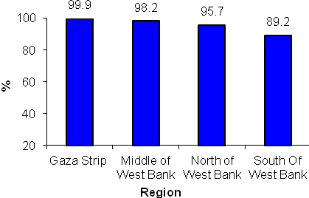

Water Consumption
The household sector in Palestine consumed about 16 million cubic meters of water per month (MCM/month) during 2013: 10 MCM/month in West Bank and 6 MCM/month in Gaza Strip. Monthly average household consumption of water in Palestine was 22.1 cubic meters (M³): 21.4 M³ in West Bank and 23.5 M³ in Gaza Strip.

Increased Connection to Wastewater Networks
Disposal of wastewater using the wastewater network increased significantly in 2013 compared to previous years. In 2013, 55.3% of households in Palestine used a wastewater network to dispose of their wastewater compared to 55.0% in 2011 and 52.1% in 2009.

Local Authority Responsible for Solid Waste Collection Service

Local authorities collected solid waste for 71.5% of households in Palestine, UNRWA collected 8.5% of solid waste, and in 2.3% of households a special contractor collected the solid waste.

Decrease in Average Daily Household Solid Waste

The average daily household waste generated in Palestine in 2013 was estimated to be 2.7 kg (3.0 kg in 2011).

Quantity of Solid Waste Generated Daily and Average Daily Household Generation of Solid Waste in Palestine by Region, 2013

Region | Total daily generated quantity (Ton) | Average household daily generation (Kg)
Palestine | 2,018.6 | 2.7
West Bank | 1,274.5 | 2.6
North of West Bank | 588.9 | 3.0
Middle of West Bank | 249.9 | 1.8
South of West Bank | 435.7 | 3.0
Gaza Strip | 744.1 | 2.8

Exposure to Noise and Smells

Around 18.5% of households in Palestine were exposed to noise very frequently and 11.2% of households were exposed to smells very frequently.

PCBS conducted the Household Environmental Survey for 2013 during the period 21/08 to 01/10/2013. The survey provides data on water consumption, solid waste generation and wastewater disposal methods by households.

