Palestinian Central Bureau of Statistics (PCBS)

Press Release on Results of Household Energy Survey (July 2013)

85% of Households in the North of West Bank Use a Prepaid Electricity Meter

About 100% of households in Palestine were connected to the public electricity network in July 2013 compared to 97.2% in the same period of 1999.

The data showed that 63.7% of households in Palestine used a normal electricity meter and 36.3% of households used a prepaid electricity meter in July 2013.

Region | Type of Electricity Meter Used
Region | Normal Meter |  | Prepaid Meter |  | Total
Palestine |  | 63.7 |  | 36.3 | 100
West Bank |  | 44.4 |  | 55.6 | 100
North of West Bank |  | 14.9 |  | 85.1 | 100
Middle of West Bank |  | 81.6 |  | 18.4 | 100
South of West Bank |  | 46.1 |  | 53.9 | 100
Gaza Strip |  | 100.0 |  | 0.0 | 100

Two-Thirds of Households Have Solar Heating The results indicated that 62.4% of households in Palestine had solar energy heating in July 2013 compared to 66.7% in July 2010.

Average Household Electricity Consumption of 260 kWh
Average household consumption of electricity in Palestine was 260 kWh in July 2013 compared to 250 kWh in July 2010.

Average of Households’ Consumption of Electricity

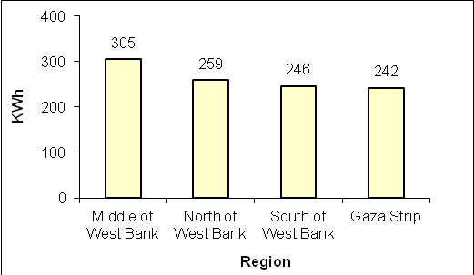

Highest Average Gasoline Consumption in the North of West Bank
Average household consumption of gasoline (in households using gasoline) in Palestine was 51 liters in July 2013. It was 82 liters in the North of West Bank, but only 23 liters in the Gaza Strip.

Drop in Average Gas Consumption
Average household consumption of liquefied petroleum gas (in households using liquefied petroleum gas) in Palestine was 15 kg in July 2013 compared to 16 kg in July 2010.

Disparity in Wood Consumption
Average household consumption of wood (in households using wood) was 55 kg in July 2013. It was 90 kg in the South of West Bank and 34 kg in the North of West Bank.

Most Households Rely on Electricity for Water Heating
The results showed that 86.8% of households in Palestine have used conditioning in July 2013, 18.7% of households in Palestine used electricity for air conditioning compared to 7.7% in July 2010; 45.3% of households used a fixed fan and 80.6% of households used a mobile fan in July 2010.

PCBS implemented the Household Energy Survey for July 2013 during the period between 21/08 to 01/10/2013. It covered energy indicators (electricity, petroleum fuel and other types of energy) used in household activities for cooking, baking, water heating and air conditioning.

Data collection of Household Energy Survey was funded by the European Union

