Palestinian Central Bureau of Statistics (PCBS)

Main results of the Palestinian Registered* External Trade in Goods and Services for 2011

Imports and Exports of Goods:
The total value of imports of goods from all countries including Israel in 2011 was USD 4,221 million, an increase of 6.6 percent compared to 2010.
Exports of goods totaled USD 720 million and increased by 25.0 percent compared to 2010.
In 2011, the deficit in the net trade balance in goods increased by 3.5 percent compared to 2010 and reached to USD 3,502 million.

Distribution of Registered Exports and Imports by trade partners:
Exports to Israel increased in 2011 by 26.5 percent compared to 2010 and reached USD 618 Million; exports to Jordan increased by 24.8 percent and reached USD 39 Million.
Exports to the European countries also increased by 46.6 percent compared to 2010 and reached USD 15 Million.
Imports from Israel was increased in 2011 by 2.3 percent compared to 2010 and reached USD 2,939 Million, imports from Jordan increased by 33.6 percent during the same period compared to 2010.
Imports from European countries Also increased by 20.8 percent in 2011 compared to 2010 and reached USD 444 Million.

Registered Imports, Exports in Goods and Net Trade Balance in the Palestinian Territory, 2000 - 2011
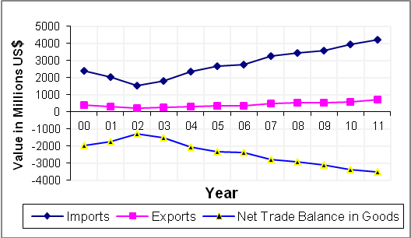

Import and export in services with Israel:
The total value of imports of services from Israel in 2011 was USD 100 Million and decreased by 23.4 percent compared to 2010.

Exports of services to Israel increased by 23.9 percent in 2011 compared to 2010 and reached USD 148 Million.

Registered Imports, Exports, Net Trade Balance in Services with Israel in the Palestinian Territory 2000 - 2011
