Palestinian Central Bureau of Statistics (PCBS)

Palestinian Registered* External Trade in Goods of June, 2012.

Exports
Exports decreased in June, 2012 by 6.4 percent compared to May, 2012 and decreased by 17.3 percent compared to June, 2011 and reached USD 60.2 Million.

Exports to Israel decreased in June, 2012 by 3.9 percent compared to May, 2012.

Also, exports to other countries decreased by 24.6 percent during the same period compared to May, 2012.

Exports to Israel represented 90.2 percent of total exports in June, 2012.

Imports
Imports decreased in June, 2012 by 7.8 percent compared to May, 2012. And decreased by 2.9 percent compared to June, 2011 and reached USD 355.9 Million.

Imports from Israel decreased by 8.1 percent in June, 2012 compared to May, 2012.

Imports from Israel represented 64.8 percent of total imports in June, 2012.

On the other hand, imports from other countries decreased by 7.0 percent compared to May, 2012.

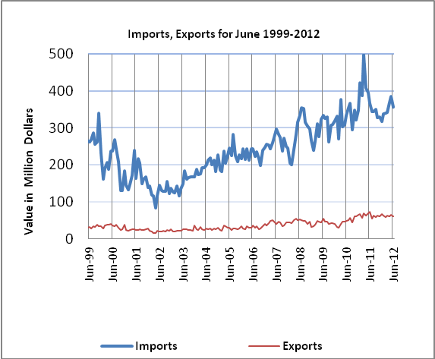

Net Trade Balance on Registered Goods
The trade balance which represents the difference between exports and imports showed a decrease in trade deficit by 8.0 percent compared to May, 2012. And increased by 0.7 percent compared to June, 2011 and reached USD 295.7 Million.

*: Includes actual data received from official sources

