Palestinian Central Bureau of Statistics (PCBS)

Preliminary Results of the Palestinian Registered* External Trade in Goods of December, 12/2017

Exports of Goods:
Palestinian Exports increased in December, 2017 by 2.5% compared to November, 2017. It also increased by 12.8% compared to December, 2016 and reached USD 95.3 million.

Exports to Israel increased in December, 2017 by 6% compared to November, 2017 and represented 85.4% of total exports in December, 2017.

On the other hand, exports to other countries decreased by 14.2% during the same period compared to November, 2017.

Imports of Goods:
Imports increased in December, 2017 by 6.3% compared to November, 2017. It also increased by 2.6% compared to December, 2016 and reached USD 469.2 million.

Imports from Israel increased by 1.7% in December, 2017 compared to November, 2017 and represented 56.6% of total imports in December, 2017.

At the same time, imports from other countries increased by 12.9% compared to November, 2017.

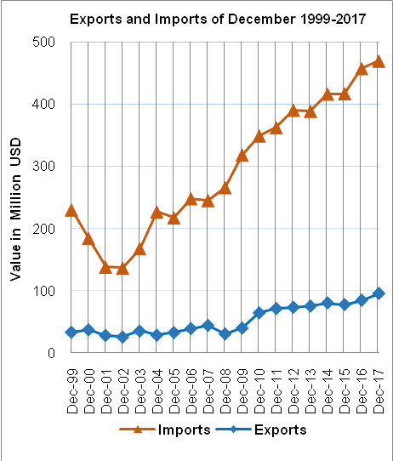

Net Trade Balance on Registered Goods:
The trade balance which represents the difference between exports and imports showed an increase in trade deficit by 7.3% in December, 2017 compared to November, 2017. While it slightly decreased by 0.3% compared to December, 2016 and reached USD 373.9 million.

Note:
*: Includes actual data received from official sources

