Palestinian Central Bureau of Statistics (PCBS)

Preliminary Results of the Palestinian Registered* External Trade in Goods of February, 02/2014.

Exports:
Exports slightly increased in February, 2014 by 0.2% compared to January, 2014 and it decreased by same percentage compared to February, 2013 and reached USD 68.8 Million.

Exports to Israel decreased in February, 2014 by 3.7% compared to January, 2014 and represented 86.7% of total exports in February, 2014.

On the other hand, exports to other countries increased by 36.5% during the same period compared to January, 2014.

Imports:
Imports decreased in February 2014 by 2.4% compared to January, 2014. While it increased by 12.3% compared to February, 2013 and reached USD 409.3 Million.

Imports from Israel increased by 0.3% in February 2014 compared to January, 2014 and represented 71.7% of total imports in February 2014.

On the other hand, imports from other countries decreased by 8.6% compared to January, 2014.

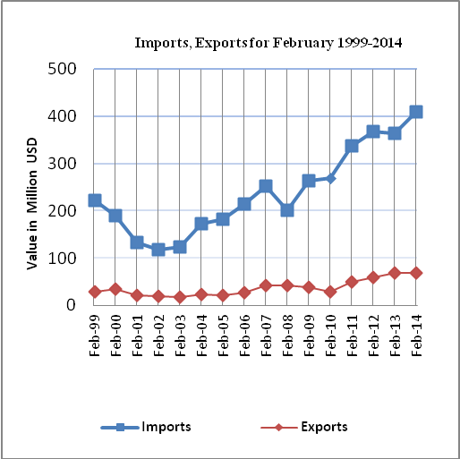

Net Trade Balance on Registered Goods:
The trade balance which represents the difference between exports and imports showed a decrease in trade deficit by 2.9% compared to January, 2014. While it increased by 15.3% compared to February 2013 and reached USD 340.5 Million.

*: Includes actual data received from official sources

