Palestinian Central Bureau of Statistics (PCBS)

Preliminary Results of the Palestinian Registered* External Trade in Goods of
November,11/2015

Exports:
Exports increased in November, 2015 by 6.6% compared to October, 2015. It also increased by 7.0% compared to November, 2014 and reached USD 81.3 Million.
Exports to Israel slightly increased in November, 2015 by 0.8% compared to October, 2015 and represented 79.2% of total exports in November, 2015
On the other hand, exports to other countries increased by 36.3% during the same period compared to October, 2015.

Imports:
Imports decreased in November, 2015 by 2.1% compared to October, 2015. While it increased by 5.2% compared to November, 2014 and reached USD 416.6 Million.

Imports from Israel decreased by 3.9% in November, 2015 compared to October, 2015 and represented 54.3% of total imports in November, 2015.

On the other hand, imports from other countries slightly increased by 0.1% compared to October, 2015.

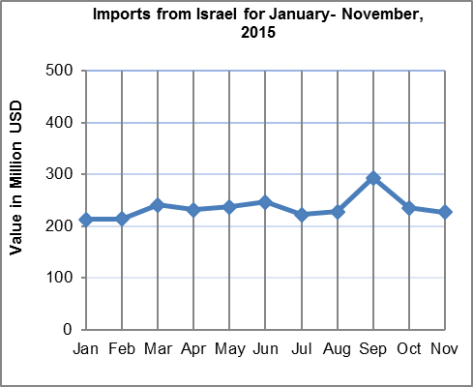

1

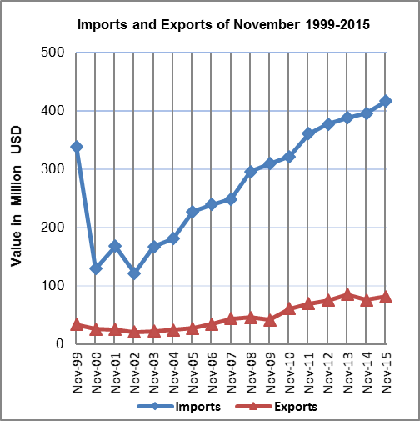

Net Trade Balance on Registered Goods:
The trade balance which represents the difference between exports and imports showed a decrease in trade deficit by 4.0% in November, 2015 compared to October, 2015. While it increased by 4.8% compared to November, 2014 and reached USD 335.3 Million.

* Includes actual data received from official sources

2

