Palestinian Central Bureau of Statistics (PCBS)

Palestinian Registered* External Trade in Goods of September, 2012

Exports:
Exports increased in September, 2012 by 3.0 percent compared to August, 2012 and increased by 2.1 percent compared to September, 2011 and reached USD 59.1 Million.

Exports to Israel increased in September, 2012 by 2.5 percent compared to August, 2012.

Exports to Israel represented 89.2 percent of total exports in September, 2012.

On the other hand exports to other countries increased by 7.7 percent during the same period compared to August, 2012.

Imports:
Imports decreased in September, 2012 by 8.1 percent compared to August, 2012. And decreased by 6.4 percent compared to September, 2011 and reached USD 328.3 Million.
Imports from Israel decreased by 1.1 percent in September, 2012 compared to August, 2012.
Imports from Israel represented 68.9 percent of total imports in September, 2012.
On the other hand, imports from other countries decreased by 20.5 percent compared to August, 2012.

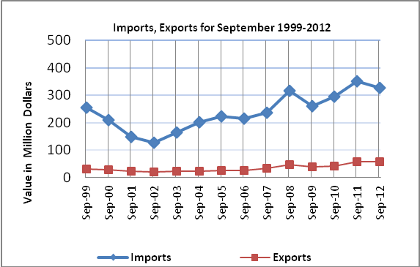

Net Trade Balance on Registered Goods:
The trade balance which represents the difference between exports and imports showed a decrease in trade deficit by 10.2 percent compared to August, 2012. And decreased by 8.1 percent compared to September, 2011 and the trade deficit reached USD 269.2 Million.

*: Includes actual data received from official sources

