Palestinian Central Bureau of Statistics (PCBS)

Palestinian Registered* External Trade in Goods of August, 2012.
Exports:
Exports decreased in August, 2012 by 6.9 percent compared to July, 2012 and decreased by 9.5 percent compared to August, 2011 and reached USD 57.3 Million.

Exports to Israel decreased in August, 2012 by 6.3 percent compared to July, 2012.

Exports to Israel represented 89.6 percent of total exports in August, 2012.

On the other hand exports to other countries decreased by 11.2 percent during the same period compared to July, 2012.

Imports:
Imports decreased in August, 2012 by 2.8 percent compared to July, 2012. And increased by 3.7 percent compared to August, 2011 and reached USD 357.2 Million.

Imports from Israel decreased by 4.0 percent in August, 2012 compared to July, 2012.

Imports from Israel represented 64.1 percent of total imports in August, 2012.

On the other hand, imports from other countries decreased by 0.6 percent compared to July, 2012.

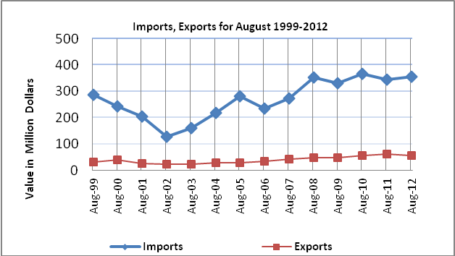

Net Trade Balance on Registered Goods:
The trade balance which represents the difference between exports and imports showed a decrease in trade deficit by 2.0 percent compared to July, 2012. And increased by 6.7 percent compared to August, 2011 and the trade deficit reached USD 299.8 Million.

*: Includes actual data received from official sources

