Palestinian Central Bureau of Statistics ( PCBS)

Preliminary Results of the Palestinian Registered* External Trade in Goods
Of October, 10/2015.

Exports:
Exports increased in October, 2015 by 20.3% compared to September, 2015. While it slightly decreased by 0.3% compared to October, 2014 and reached USD 76.3 Million.

Exports to Israel increased in October, 2015 by 12.6% compared to September, 2015 and represented 83.7% of total exports in October, 2015.

On the other hand, exports to other countries increased by 84.5% during the same period compared to September, 2015.

Imports:
Imports decreased in October 2015 by 5.5% compared to September, 2015. While it increased by 7.9% compared to October, 2014 and reached USD 425.6 Million.

Imports from Israel decreased by 19.6% in October 2015 compared to September, 2015 and represented 55.3% of total imports in October 2015.

On the other hand, imports from other countries increased by 20.7% compared to September, 2015.

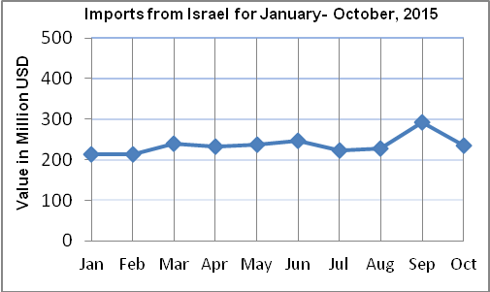

*: Includes actual data received from official sources

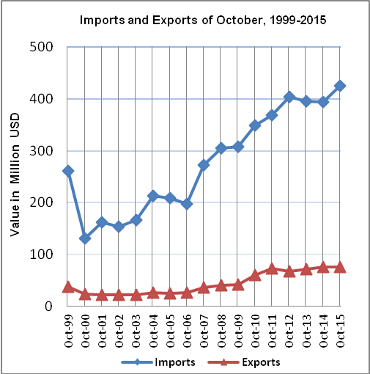

Net Trade Balance on Registered Goods:
The trade balance which represents the difference between exports and imports showed a decrease in trade deficit by 9.7% in October 2015 compared to September 2015. While it increased by 9.8% compared to October 2014 and reached USD 349.3 Million.

