Palestinian Central Bureau of Statistics (PCBS)

Preliminary Results of the Palestinian Registered* External Trade in Goods of
March, 03/2014.

Exports:
Exports increased in March, 2014 by 6.5% compared to February, 2014 and increased by 13.5% compared to March, 2013 and reached USD 73.3 Million.

Exports to Israel increased in March, 2014 by 7.2% compared to February, 2014 and represented 87.2% of total exports in March, 2014.

On the other hand, exports to other countries increased by 2.4% during the same period compared to February, 2014.

Imports:
Imports increased in March 2014 by 2.2% compared to February, 2014. It also increased by 23.3% compared to March, 2013 and reached USD 418.1 Million.

Imports from Israel decreased by 2.6% in March 2014 compared to February, 2014 and represented 68.4% of total imports in March 2014.

On the other hand, imports from other countries increased by 14.2% compared to February, 2014.

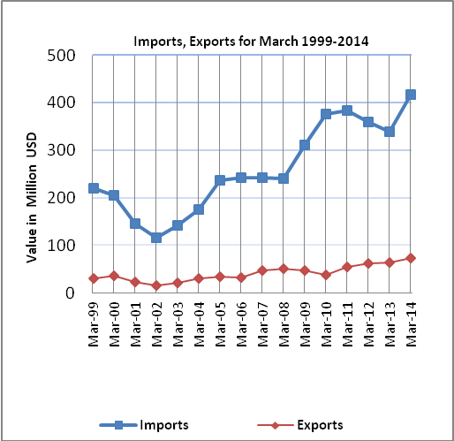

Net Trade Balance on Registered Goods:
The trade balance which represents the difference between exports and imports showed an increase in trade deficit by 1.3% compared to February, 2014. And increased by 25.6% compared to March 2013 and reached USD 344.8 Million.

*: Includes actual data received from official sources

