Palestinian Central Bureau of Statistics (PCBS)

Palestinian Registered* External Trade in Goods of March, 03/2013.

Exports:
Exports decreased in March, 2013 by 6.3% compared to February, 2013 and increased by 4.9% compared to March, 2012 and reached USD 64.6 Million.

Exports to Israel decreased in March, 2013 by 6.0% compared to February, 2013 and represented 89.3% of total exports in March, 2013.

On the other hand exports to other countries decreased by 8.6% during the same period compared to February, 2013.

Imports:
Imports decreased in March, 2013 by 6.9% compared to February, 2013. And decreased by 0.7% compared to March, 2012 and reached USD 339.2 Million.

Imports from Israel decreased by 7.3% in March, 2013 compared to February, 2013 and represented 69.2% of total imports in March, 2013.

On the other hand, imports from other countries decreased by 6.1% compared to February, 2013.

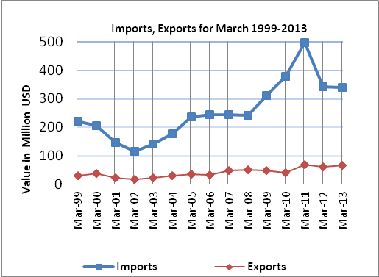

Net Trade Balance on Registered Goods:
The trade balance which represents the difference between exports and imports showed a decrease in trade deficit by 7.0% compared to February, 2013. And decreased by 1.9% compared to March, 2012 and reached USD 274.6 Million.

*: Includes actual data received from official sources

